Notes 4.2: Using Scientific Notations to Describe Very Large quantities
Focus Question: How can positive powers of 10 make large numbers easier to write and compare?
Vocabulary:
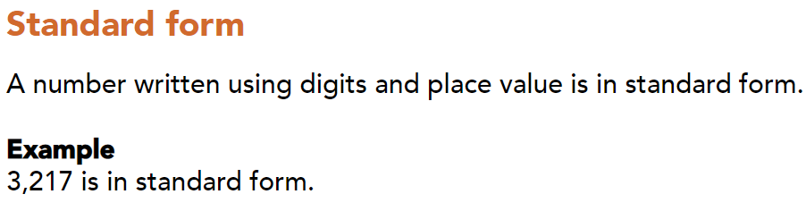
Part1
Example:
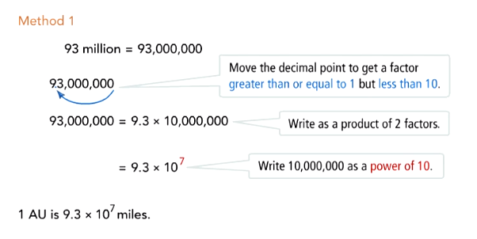
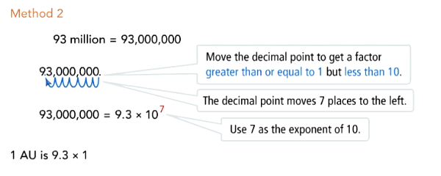

Part1 Try:

Part2:Example
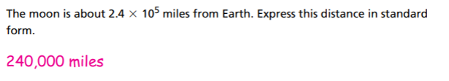
Part3: Example
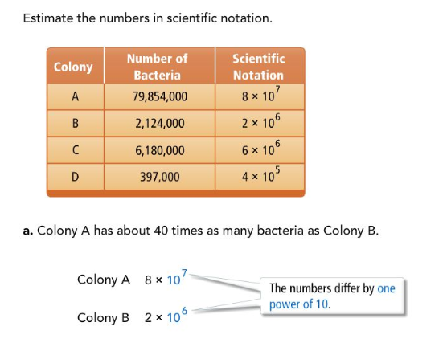
Part3 Try:
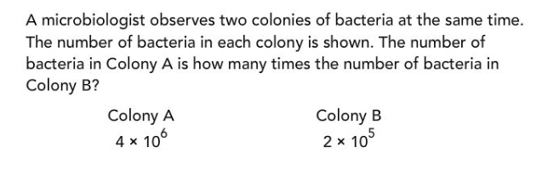

Summary:
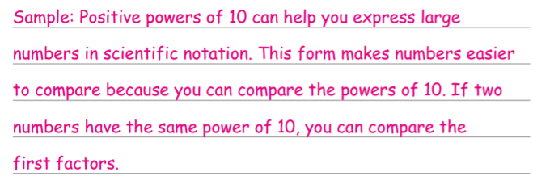
Answers
Part1 Try:
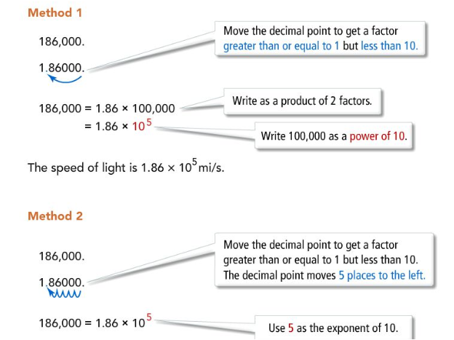

AnswerPart3 Try:
