Science, 5th Period, 4th Quarter 2019-2020, Ms. Angell, April 27th – May 1st
- MS-LS1-4 - animal and plant behaviors are specialized, and those specializations increase the likelihood (probability) that the plant or animal will have offspring that are successful (grow up).
- MS-LS1-5 – environmental and genetic factors influence growth
- MS –ETS1-3- Analyze data regarding possible solutions and optimal design solutions
Final Products – Tough Concepts – Go With it – Gain Knowledge, Persevere!

- Prewrite, Watch and respond to TED Ed: “How to Spot a Misleading Graph”
How to spot a misleading graph - Lea Gaslowitz

- Prewrite, Watch and Respond to TED Eds:
- The evolution of the human eye - Joshua Harvey
- Myths and misconceptions about evolution - Alex Gendler

- TED Ed “How to Spot a Misleading Graph” How to spot a misleading graph - Lea Gaslowitz

Phenomenon: Humans communicate, but often are not honest in their communications.
Essential question: How can graphs of data facts be misleading?

Background: Graphs organize data to tell a story. If the graphs are misleading, the story is not accurate.
Key Terms: graph – line and bar, data, points, labels (numbers), axis, scale, context (story)

A. Think about the phenomenon and the essential question.
B. Respond to the quick write: What are your thoughts about lying?
C. Watch the video one time through, then the video sections as many times as needed.
D. Explain (in a sentence or two) the main idea of each of the following video sections:
- 0:30 to 1:35 seconds (bar graphs and scale distortion)
- 1:30 to 2:15 (line graph and scale distortion)
- 2:00 to 2:24 (cherry picking – what is the whole story?)
- 2:24 to 2:50 (leaving out data)
- Entire video: write 2 ahas!
- Essential Question - Big idea: You need to pay attention to what four things to help you figure out a graph’s accuracy - how can graphs of data facts be misleading?
- Bonus question – why did the videographer have the viewer change color (yellow to turquoise)?

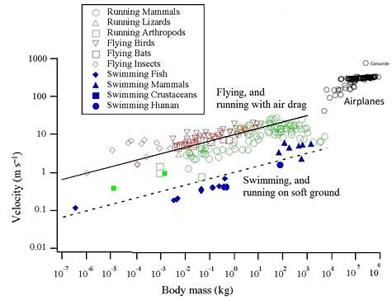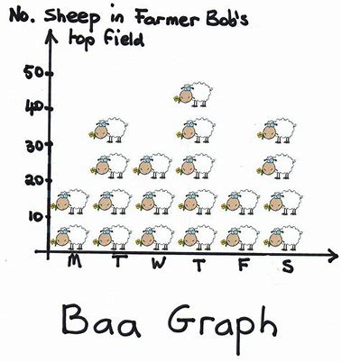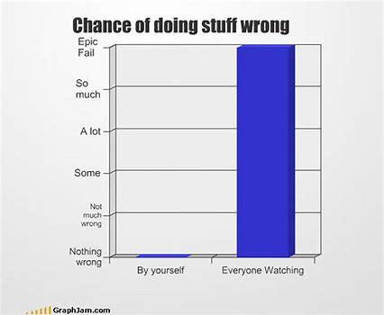
This is crazy complex but cool! Pictograph, actually Um, yeah! ;)

B1 TED Ed – eyeballs! The evolution of the human eye - Joshua Harvey

Phenomenon:
The ability to see varies among species.
- Humans cannot see well at night.
- Cats can.
- Insects see different wavelengths of light than mammals.
- Some fish can see above and below water surfaces at the same time. Some fish are blind. ;)
- Chameleon eyes work independently of each other.

Essential Question:
Why do different species have different abilities?

Tasks
Background: Sight is an ability that varies among species and has changed over time.

- Think about the phenomenon and the essential question.
- Respond - quick write: Would you rather have night vision or x-ray vision? Explain.
- Watch the video one time through, then the video sections as many times as needed.
- Write an aha (big idea) for each of the following video sections:
- 0:00 – 0:45 seconds
- 0:45 – 1:20
- 1:20 – 1:50
- 1:45 – 2:30
- 2:55 – 3:55
- 3:55 – 4:28
- Give 2 ahas for the entire video and two questions.
- Bonus question: Write your thoughts on why are cavefish blind (“What do Fish Have to do with Anything?”).

- Essential Question Big idea: Write your thoughts (a few sentences) about
why different species have different abilities.

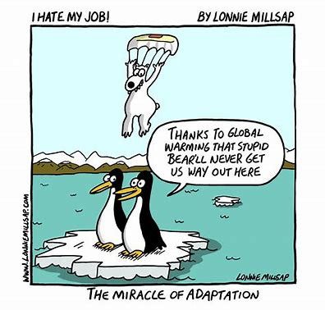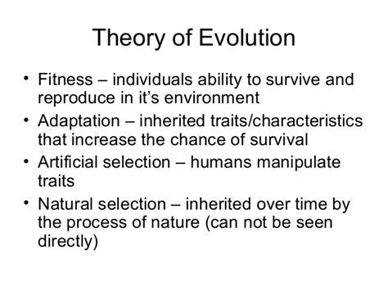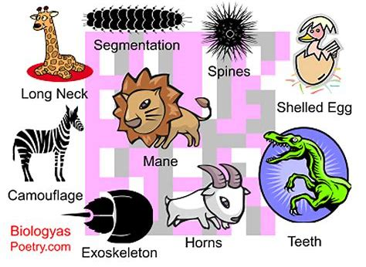

B2 TED Ed – evolution! Myths and misconceptions about evolution - Alex Gendler

Phenomenon:
Animal and plant species change over time.
- Dolphins were once four legged land mammals.
- Birds like penguins and kiwis lost the ability to fly.
- Snakes once had four legs.
- Giraffes with long necks were once like okapis with shorter necks.

Essential Question:
How does change in a species’ characteristics occur?

Tasks
Background: an animal or plant’s species’ success is through reproduction,
and having its offspring survive.
Successful reproduction and offspring survival is dependent on adaptations to an environment.
Polar bears are not going to make it in the Sahara Desert!

A Think about the phenomenon and the essential question.
B. Respond - quick write: How might human bodies/adaptations need to change to survive on the moon?
C. Watch the video one time through, then the video sections as many times as needed.
D. Write an aha (big idea) for each of the following video sections:
- 0:00 – 1:25
- 1:25 – 2:00
- 2:00 – 2:45
- 2:45 – 3:30
- 3:30 – 3:55
- 3:55 – 4:07
E. Give 2 ahas for the entire video, and two questions.
F. Bonus question: write an opinion paragraph about Charles Darwin’s quote (scientist: evolution theory) below.

G Essential Question Big idea: write your thoughts ( a few sentences) about
how change in a species’ characteristics occurs.

Grading: regular rubric
Turning in product: turned into Williams, or photographed and sent to cangell@tusd.net

Questions: cangell@tusd.net Email anytime of course, but online hours I will be actively replying in real time will be 11am - 1:00pm (and checking email frequently)

Read/reread the attached two articles for additional ideas

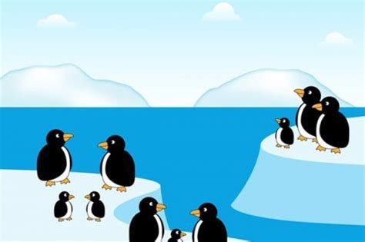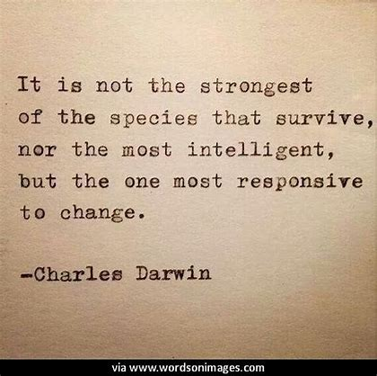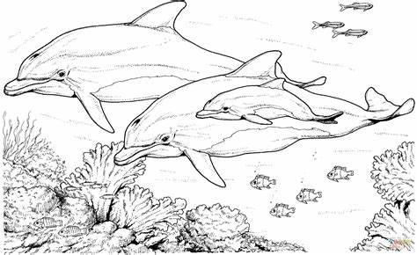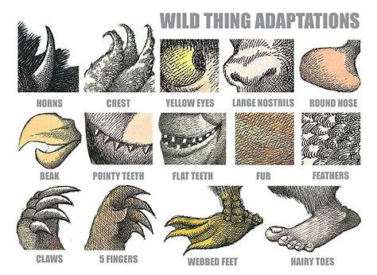
2020 WWF - World Wide Fund For Nature: Habitat and Nature

Every organism has a unique ecosystem within which it lives. This ecosystem is its natural habitat. This is where the basic needs of the organism to survive are met: food, water, shelter from the weather and place to breed its young. All organisms need to adapt to their habitat to be able to survive.
This means adapting to be able to survive the climatic conditions of the ecosystem, predators, and other species that compete for the same food and space. An adaptation is a modification or change in the organism's body or behavior that helps it to survive.
An animal may adapt to its habitat in different ways. It may be a physical or structural adaptation, just as the limbs of birds have modified into wings or the way the cheetah is shaped for running at a fast speed.
It may be in the way the body works in circulating and respiration, for instance the gills that fish have enable them to breathe in water. Or it may be the way the animal behaves whether it is hunting for food, or running fast to avoid predators or migrating to other places for food or survival.
An animal's environment consists of many different things. The climate, the kinds of food plants that grow in it, other animals that may be predators or competitors- the animal must learn to adapt to each of these factors in order to survive. With increasing population growth and human activity that disturbs the natural habitat, animals must learn to adapt to these kind of threats as well.
Animals in the wild can only live in places they are adapted to. They must have the right kind of habitat where they can find the food and space they need.
Did you know that animals camouflage themselves so they can adapt to their environment? Adaptation can protect animals from predators or from harsh weather. Many birds can hide in the tall grass and weeds and insects can change their color to blend into the surroundings. This makes it difficult for predators to seek them out for food.
Some animals, like the apple snail, can survive in different ecosystems- from swamps, ditches and ponds to lakes and rivers. It has a lung/gills combination that reflects its adaptation to habitats with oxygen poor water. This is often the case in swamps and shallow waters.
In the harsh cold climate of Alaska, the animals have learnt to adapt to the weather by storing food in their body and protecting themselves from the cold with thick furs. Human inhabitants in Alaska have also learnt to cope with the environment by building shelters that insulate and hold the heat, and yet do not allow the structure to melt.

- Kidzsearch.com Adaptation
Adaptation is the evolutionary process where an organism becomes better suited to its habitat.^{[1][2]} This process takes place over many generations.^{[3]} It is one of the basic phenomena of biology.^{[4]}
When people speak about adaptation, they often mean a feature (a trait) which helps an animal or plant survive. An example is the adaptation of horses' teeth to grinding grass. Grass is their usual food; it wears the teeth down, but horses' teeth continue to grow during life. Horses also have adapted to run fast, which helps them to escape their predators, such as lions. These features are the product of the process of adaptation.
…bird beaks show an obvious sign of their different ways of life. However, eating a different food also means having a different digestive system, gut, claws, wings and above all, different inherited behavior. For the major adaptations, what changes is not a single trait, but a whole group of features.
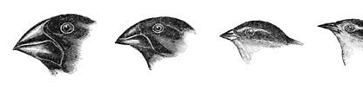
Adaptation occurs because the better adapted animals are the most likely to survive, and to reproduce successfully. This process is known as natural selection; it is the basic cause of evolutionary change.^{[5]}

Ecological niches
All adaptations help organisms survive in their ecological niches. This implies an increase in biological fitness.
These adaptive traits may be structural, behavioral or physiological.
Structural adaptations are physical features of an organism (shape, body covering, armament; and also the internal organization).
Behavioral adaptations are composed of inherited behavior chains and/or the ability to learn: behaviors may be inherited in detail (instincts), or a tendency for learning may be inherited (see neuropsychology). Examples: searching for food, [mating], vocalizations.
Physiological adaptations permit the organism to perform special functions (for instance, making venom, secreting slime, phototropism); but also more general functions such as growth and development, [and] temperature regulation...
Adaptation, then, affects all aspects of the life of an organism.

