Week 5 (optional) Assignments

- Create a yard sign announcing to the neighborhood that you are a promoting 8th grader and will be a high school student next year. Include on your sign, Williams Middle School, promoting year of 2020, your name (if that is approved by your parents/guardians), and the school mascot (wildcat). Make it colorful, big (so people can read it from the street), and neat. Text or email me a picture, I would love to see them, to celebrate with you.
- Write a letter. This letter (or email) written to a parent/relative/sibling, a teacher, a coach, a friend, anyone who is important to you. Include in the letter how much you learned this year from that person, thank them for their help or just being there, and explain what you are going to do next year to achieve your goals. This is the perfect time to write someone. You could really make someone’s day special.
- Make something to celebrate your promotion. You can bake a cake, decorate a sign, sew or knit something, help in the garden, do anything creative to celebrate. Text or email me a picture of the final product.
- Art projects on the following page. Please email any artwork to my email or text me a picture so I can see your creative work.

Frank Stella Protractor art:
- Not only is Frank Stella still alive but he is one of Ms. Bacchetti’s favorite artists.
- He was born May 12, 1936 in Malden, Massachusetts.
- He is an American painter, sculptor and printmaker, noted for his work in minimalism and abstraction. He lives and works in New York City.
- Research online to see some of his art; I will include a couple here.
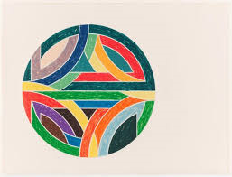
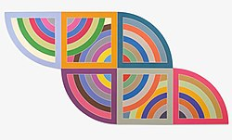

Golden Ratio:
- The Golden Ratio exists when a line is divided into two parts and the longer part (a) divided by the smaller part (b) is equal to the sum of a + b divided by a, which both equal 1.618
- You can YouTube Donald in Mathmagic Land, it is a good explanation of the Golden Ratio and how it appears in nature, music, and games.
- Find something in nature that is an example of the Golden Ratio (flowers, pinecones, be creative) and create your own artwork as an example of this ratio.
- Be creative or take a picture
- Use any form of materials you may have in the house.
- Send me a picture of any artwork or photographs when finished.

