Mr. Kerin, Art Class, Week 2 Assignment- Banksy
Read the following biography on mysterious artist Banksy, and then do the assignment that follows. Again, you can take a picture and email it to me.

About Banksy Biography from streetartbio.com
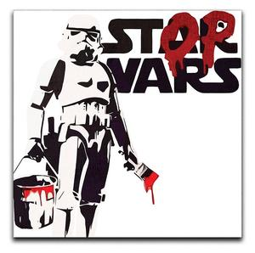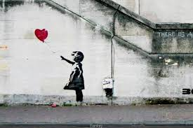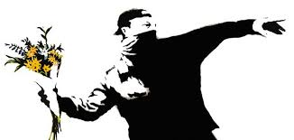
Arguably the most controversial street artist in the world, Banksy has developed an entire art subculture devoted to his works. Banksy’s art can impact any location at any given moment. His identity remains unknown, even after over 20 years of being involved with the graffiti scene. He has worked with many different types of street art media and street art types. His work not only includes many powerful, often controversial images, but they may also be found throughout the Internet as viral images.
Banksy began his graffiti art lifestyle by admiring the works of Blek Le Rat and often recycling his old ideas. He has been very active in the graffiti scene since the early 1990s. Initially, he hung around a graffiti crew in Bristol by the name of DryBreadZ crew or DBZ. Soon after, he began to partner with Inkie, another notable graffiti street artist.
By the age of 18, Banksy began to develop stencils after nearly being caught vandalizing public spaces by police. As his crew fled from the scene, Banksy was stuck hiding beneath a garbage truck. It was at this time that Banksy saw stencil letters on the truck. Looking for a faster way to paint, Banksy decided stenciling would be his new graffiti type.
The most common form of street art Banksy uses are stencils. These are often in the form of multi-layered stencils and/or combined with other media sources, such as spray-paint. He also includes anything found in the streets like street signs and other objects to convey his message by crafting beautiful street art installations. His artwork is often satirical and combines dark humor with graffiti and also spread messages across art, philosophy, and politics.
By the early 2000s, Banksy relocated to London, where he began to gain notoriety and even worked on a series of international exhibits. Eventually, he decided to travel to Palestine and the West Bank, where he stenciled nine images on the Bethlehem Wall. These images were an instant hit and virally exploded in the Internet.
At this time, Banksy’s silkscreen prints and stencil paintings were racking up record-breaking sales in storied art auctions such as Sotheby’s and Bonham’s of London. These successful sales officially broke him into the commercial business. In 2010 Banksy became a successful author and filmmaker for the film “Exit Through the Gift Shop.”
Very little is known about Banksy himself, as he refuses to be interviewed and keeps his identity carefully maintained. A world-renowned mystery man, Banksy has risen through the ranks to become one of the world’s greatest street artists partly by creating an urgency to understand his character. Street art fanatics are consistently satisfied with every piece of art he delivers, though he often leaves them wanting more. This tactic carries one’s curiosity to explore a completely new perspective or idea, leaving his artistic creations to inspire beginning and advanced artists. This inspiration is also known as the “Banksy Effect.”
The media and his supporters have always questioned Banksy’s identity due to a variety of identity claims. Most recently, many popular theories, including an entire newspaper publication, pointed his identity at being a Bristol native by the name of Robin Gunninham. If this is theory holds true, it will allow even greater insight into the artistic world Banksy inhibits. What is even more interesting is that he has managed to completely conceal his identity from his family. To this date, no Banksy identity claim has ever been definitive.
In Summer 2015, Banksy organized a temporary art project called Dismaland, a dystopian theme park built in the seaside resort town of Weston-super-Mare, in England. Prepared in secret, the project unveiled 10 new works by Banksy and the pieces from 58 other artists.
Banksy’s artwork has been seen across the world. His travels have included Australia, England, the United States, Israel, Jamaica, and even Canada. Most recently, he spent an entire month glamorizing New York City with his street art, which grabbed the attention of thousands every day.

Assignment/Instructions:

You can see, Banksy is quite the hot topic in the art world today. Who is he/she? Nobody knows for sure. People have cut his pieces off of walls and tried to sell them, there was an HBO documentary made about him, and he just recently made news again when one of his paintings that had just sold at auction suddenly activated and shredded itself on the way out of the frame. Wild! Ok, students, this week, you are going graffiti artist. Have a message you want to put out there, whether serious or funny. Draw a street wall as the background and then draw your item with your message. Banksy often uses popular images like Star Wars or Disney, but, really, anything you like can be done. It should have a message written with it. Don’t overthink it. It doesn’t have to change the world. It just has to be a message YOU would like to put out there. So, you have a colored graffiti picture with a message put on top of what should look like a real wall. You can take a picture of it and send it to me with your name and period with it, or you can drop it off during the next drop off period. Warning: you probably will not get your work back, so keep that in mind, as it’s the end of the year. Call/email me with any questions!

