11.3 Interior Angles of Triangles
Essential Question: How is a straight angle related to the angles of a triangle?
Vocabulary:
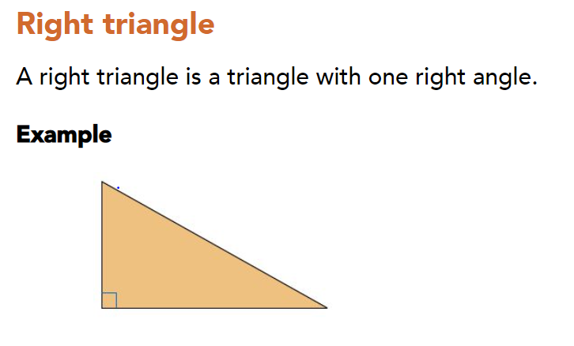
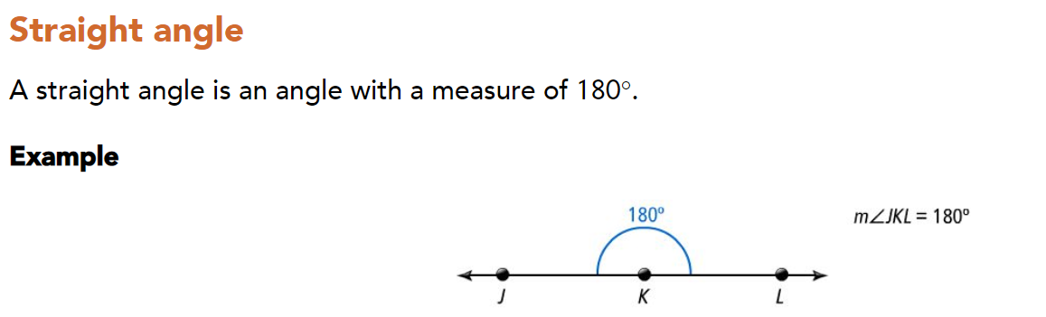
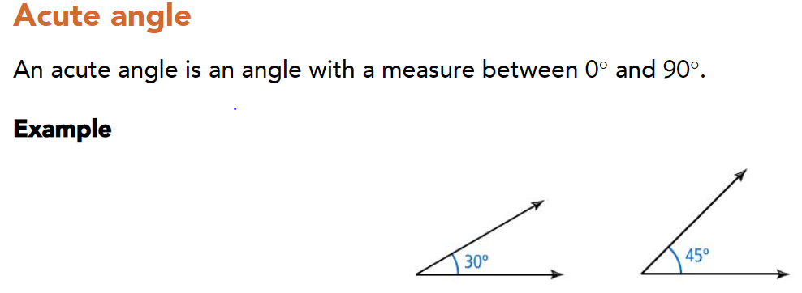
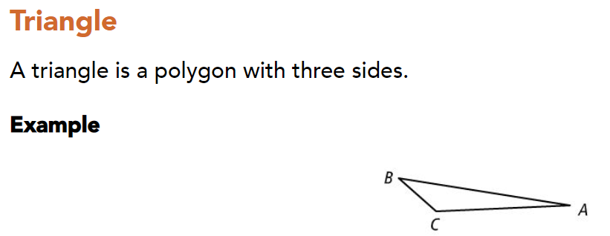

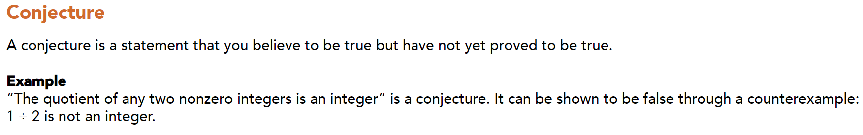
Notes: The sum of the measures of a interior angles of a triangle is 180⁰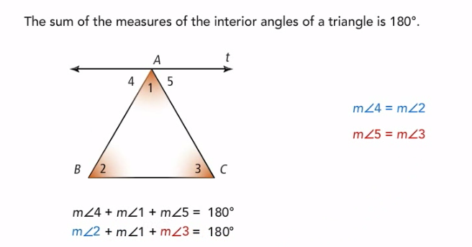
Part1:
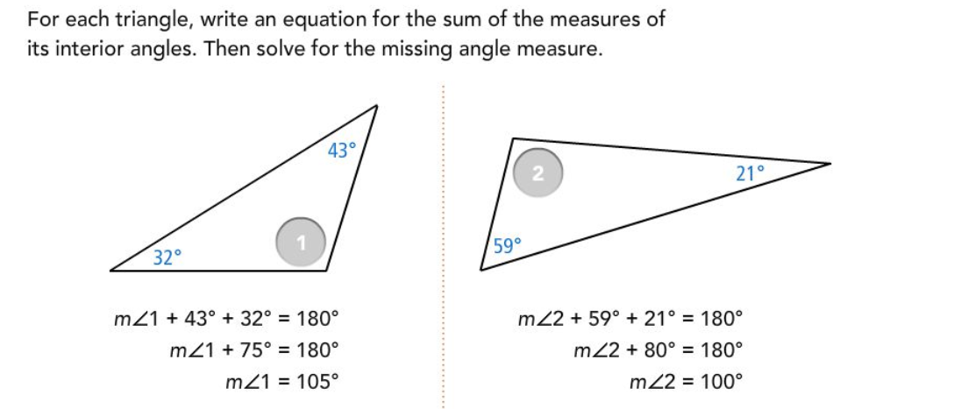

Try:
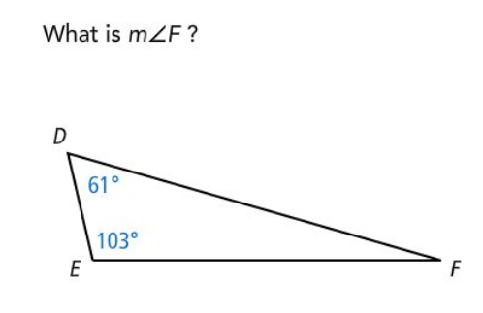 Answer______________

Part2:
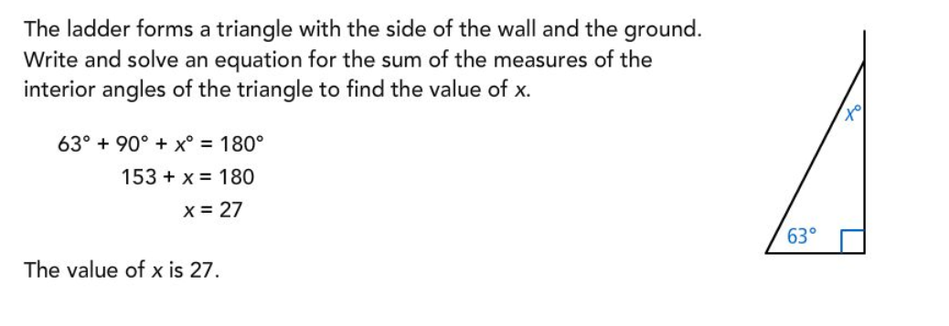

Try:

Answer_______________________
Part3:

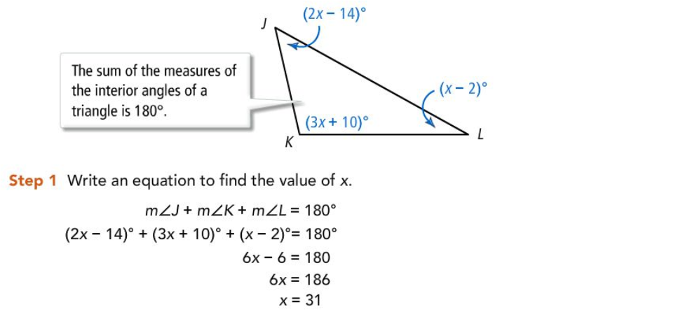
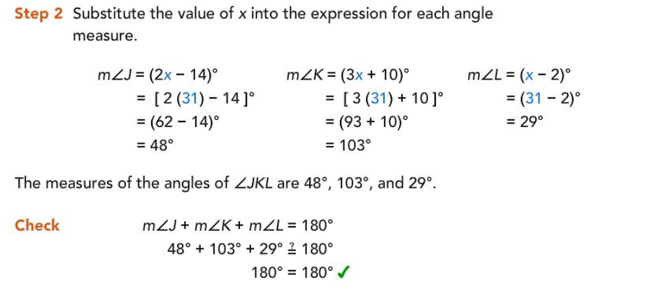

Try:
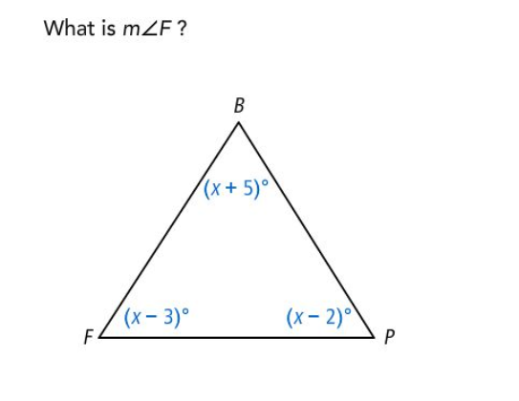Answer______________

Summary:

Answers:
Part 1 Try: 16⁰
Part 2Try:47.6⁰
Part 3 Try:57⁰

