How to make a Volcano
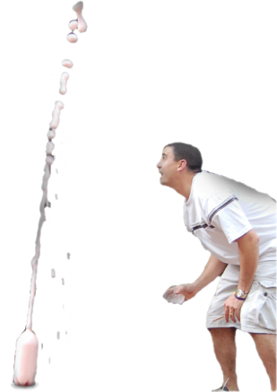

Materials:
- 10 ml of dish soap
- 100 ml of cold water
- 400 ml of white vinegar
- Food coloring
- Baking soda slurry (fill a cup about ½ with baking soda, then fill the rest of the way with water)
- Empty 2 liter soda bottle

Instructions:
NOTE: This should be done outside due to the mess.
- Combine the vinegar, water, dish soap and 2 drops of food coloring into the empty soda bottle.
- Use a spoon to mix the baking soda slurry until it is all a liquid.
- Eruption time! … Pour the baking soda slurry into the soda bottle quickly and step back!

How it Works:
A chemical reaction between vinegar and baking soda creates a gas called carbon dioxide. Carbon dioxide is the same type of gas used to make the carbonation in sodas. What happens if you shake up a soda? The gas gets very excited and tries to spread out. There is not enough room in the bottle for the gas to spread out so it leaves through the opening very quickly, causing an eruption!

