Renting vs Owning
Renting

Vocabulary:
Landlord: A person who owns property and rents it to another.
Lease: A written contract specifying the terms for the use of a property and the legal responsibilities of the property owner and tenant.
Rent: A periodic payment for a place to live.
Tenant: A person who pays rent; the legal name for a renter.

Introduction
Almost everyone will rent a place to live at some point in their life, and convenience is probably the primary reason that people choose their housing option. Renting a house or an apartment has many advantages over buying, depending upon a person's needs. It also offers many choices to consider before signing a lease. Because a lease is a legal contract, it is important to understand the terms. Otherwise, that fun, cool place to live can become a financial nightmare.

Finding your first apartment is a big step. You want to know the monthly rental cost, how much you can afford to spend monthly, and If you will have roommates.

When setting your budget for renting a place to live, be sure to include renter’s insurance. Even though your personal property may not be expensive, replacing it can be costly. You may encounter the following costs before or shortly after moving into a new apartment.

Security Deposit: Property owners require a security deposit to cover property damage, delinquent rent, broken leases, and other incidentals.

First Month’s Rent: Most landlords require the first month’s rent upfront. If you move in the middle of the month, your property owner may accept a prorated rent payment.

Moving Costs. Like homebuyers, renters have to pay to move their belongings.

Recurring Costs:
- Monthly Rent: Unless you live in a rent-controlled neighborhood or a city with strict renter protection laws, your rent can increase whenever you sign a new lease. Rent payments vary widely based on local market conditions, number of occupants, and the size, condition, and location of the rental.
- Pet Rent: Instead of a pet deposit, some landlords charge pet rent. Pet rent spreads the expected cost of pet-related wear and tear over the tenant’s entire stay. It usually amounts to $10 to $40 per month, depending on the animal and base rent.
- Renters Insurance: Renters are not required to carry renters insurance for their possessions, but it’s highly recommended to protect against loss due to theft, fire, and other perils.
- Utilities: Utilities vary by property owner and region. All utilities like PG &E, water, garbage, cable, Internet… may be included in the monthly rent, or renters may be responsible for these utilities.
- Laundry: Many rentals don’t have in-unit laundry machines. Tenants either need to find a nearby laundromat or use coin or card-operated machines onsite.

Advantages of Renting:
- Fewer responsibilities
- Unsure about their long-term housing needs
- Limited resources for a down payment.
- Maintenance-free lifestyle without worrying about the cost of repairs
- It is much easier to budget how much you spend in housing.
- You also do not need to worry about mowing the yard or other outside maintenance s
- Someone else to take care of both inside and outside maintenance matters
- Apartment complexes tend to offer a wide variety of amenities as part of your lease payment.
- Including everything in one payment makes it more affordable and more convenient.
- Flexible in case of a job change or other changes in your lifestyle. If you decide to pack up and move, you only need to work within your lease requirements
- Leases are temporary, lasting for six months or a year.
- When renting, your only financial obligation is the security deposit (usually one- or two-month’s rent) and the monthly lease amount.

Disadvantages of Renting:
- Subject to terms of a lease;
- Rent may change with little notice;
- Less privacy and transient neighbors;
- Restrictions on noise level and/or pets;
- Fewer opportunities to upgrade apartment (i.e. new carpet, paint, or wallpaper);
- When leaving a property, no equity is returned as it would be if selling a home;
- No tax deductions;
- May lose rental if the property is sold.
- Lack of control over the property and a lack of privacy.
- The owners or managers of the property are responsible for all repairs and general upkeep. However, if they do not respond quickly, you may be stuck living in a less-than-desirable situation.
- If you are paying the utility bills and have to go for several months with a leaky faucet, it increases your water bill.
- Broken windows or other problems can become safety or health issues when the landlord fails to respond to your request for repairs.
- Renting a house or an apartment may include several restrictions.
- Property owners may also limit the number of overnight guests, not allow pets or children in the apartment, and place other controls on your personal behavior.
- Once there, you are obligated to abide by whatever conditions are agreed to in the contract.
- Renting also does not allow you to build equity or get any tax benefits, both of which are important considerations for homeowners.

Because finding a place to live is a personal choice, the advantages and disadvantages are also personal. In the table below list the top ten advantages and disadvantages of renting.

Advantages (50 points) Disadvantages

Congratulations on Your New Apartment. Once you have signed the lease, it is now your apartment!

Owning
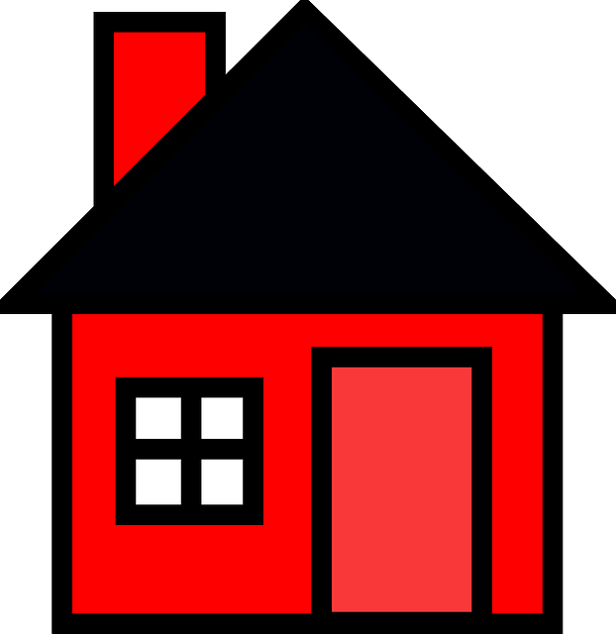

As you build careers, save money, and start families, many choose to buy a home. Are you a renter interested in buying a home or a homeowner wondering whether renting makes more sense at this point in your life? It’s time to evaluate the relative costs, benefits, and drawbacks of owning versus renting your home.

Vocabulary:
Upfront & Closing Costs: Buying a home entails numerous upfront costs:

Paid out-of-pocket: After the seller accepts your purchase offer, you have to pay an out-of-pocket-cost

Earnest Money: To show the seller you are serious about buying the property, it is customary to accompany your purchase offer with an “earnest money” check. Earnest money generally ranges from 1% to 3% of the home’s purchase price, and the amount is credited against your closing costs.

Down Payment: Your down payment is the percentage of the home’s purchase price that you pay upfront, typically at closing. It typically ranges from 3.5% to more than 20% of the purchase price.

Home Appraisal: To ensure that the offer price matches the actual value of the home, lenders require a home appraisal prior to approving the loan. Appraisal costs, typically $300 to $500, are paid during or before the appraisal.

Home Inspection: Licensed home inspectors are trained to find potential problems and defects that might not be apparent to an inexperienced buyer doing a casual walk-through. For this reason, buyers are strongly encouraged to get one, even though private lenders rarely make loan approval conditional on a completed home inspection.

Recurring Costs:
Homeownership also involves many recurring costs.
- Loan Payments: You need to make monthly principal and interest payments for the life of your mortgage loan, usually 15 or 30 years. If you have a fixed-rate mortgage, your loan payment remains constant for the full term.
- Property Taxes: Your city or county sets your property taxes, which pay for local schools, infrastructure, and other critical services. You pay one-twelfth of your annual property taxes monthly.
- Homeowners Insurance: Homeowners insurance premiums can vary from year to year based on changes in your home’s appraised value. As with property taxes, you pay one-twelfth of your annual homeowners’ premium with your monthly payment.

Advantages of Buying:
- Personal and financial goals;
- Personal values, needs, and wants;
- Amount of money available for housing costs;
- Financial resources and readiness;
- Credit history;
- Real estate prices;
- Location preference;
- Expected length of stay in a particular place
- Building Equity Over Time
Unlike renters, homeowners build equity over time. On most mortgages, a portion of each monthly payment goes toward the loan’s interest. The remainder pays down its principal. Every dollar you put toward your loan’s principal represents a dollar of equity – actual ownership of the property
- Boost your home’s value
Investments in home improvement can increase you home value. For instance, the home my wife and I recently purchased has only a rutted dirt driveway with a small shed at the end. Paving the driveway and building a proper detached garage in place of the shed would substantially increase the property’s value by an amount greater than the project’s total cost.

- Federal Tax Deductions.
If you itemize your federal income taxes, you can deduct your property taxes and the interest paid on your mortgage, reducing your overall income tax burden.
- Potential for Rental Income
Even if you don’t initially think of your home as an investment property, you can turn it into a source of income by renting.
- More Creative Freedom
As a homeowner, you can decorate, renovate, or build to your heart’s content.
- Sense of Belonging and Community
Since homeowners tend to stay in their homes for longer than renters, they’re more likely to settle in their communities.

Disadvantages of Buying
- Large down payment;
- Move-in costs;
- Insurance costs;
- Possible for property to decrease in value;
- Time, money, and energy commitment;
- Property taxes can raise substantially;
- Money is tied up in the home;
- May take several months to sell a home if trying to relocate.
- Potential for Financial Loss
Although homeownership builds equity over time, equity doesn’t equate to automatic profit. If home values in your area decrease or remain flat during your tenure as a homeowner, dragging down the appraised value of your home, you risk a financial loss when you sell.
- Responsibility for Maintenance and Repairs
As a homeowner, you’re responsible for covering the cost of all uninsured maintenance and repair work on your home.
- High Upfront Costs
Though upfront home buying costs vary greatly depending on the size of the down payment and the value of the home, you can expect to shell out no less than 5.5% to 20% of your home’s value

Advantages (50 points) Disadvantages

Define the following terms: (30 points)
- Landlord
- Tenant
- Lease
- Rent
- Security Deposit
- Moving Costs
- Renters Insurance
- Utilities
- Closing Costs
- Down Payment
- Home Appraisal
- Home Inspection
- Loan Payments
- Property Taxes
- Homeowners Insurance

 | Example 1: Maria Sanchez | Example 2: Frankie Williams
Loan amount | $ 120,000 | $ 100,000
Term in years | 30 | 30
Interest rate | 7% | 7%
Discount points | 1 | 1
Origination fee | 0 | 0
Other loan costs | 1,500 | 1,000
State & fed tax rate | 38% | 24%
Appraised value | $ 145,000 | $ 125,000
Yearly property tax | 2,500 | 2,000
Yearly homeowners insurance | 600 | 650

Answer the following questions using the above table. (20 points)

If Maria’s down payment is 20% of the loan amount, what is her down payment?
Answer: _____________________________
Calculations: _______________________________________________________

What is Frankie’s monthly recurring costs: ______________________________?
Calculations: ______________________________________________________

What is Maria’s monthly loan payment: _________________________________?
Calculations: _______________________________________________________
___________________________________________________________________

What is Frankie’s annual tax deductions: _________________________________
Calculations: _______________________________________________________
___________________________________________________________________

 | Donnelle | Sean
Monthly rent | $700 | $800
Monthly renter's insurance | $15 | $15
Annual rent increase | 4% | 4%
Purchase price | $125,000 | $100,000
Appraised value | $125,000 | $100,000
House appreciation rate | 3% | 3%
Savings rate | 4% | 4%
Your state + federal tax rate | 38% | 26%
Years before sell/pay off loan | 7 | 7
Loan amount | $100,000 | $90,000
Term in years | 30 | 30
Interest rate | 7% | 7%
Discount points | 1% | 1%
Origination fee | 0 | 0
Other loan costs | $1,000 | $1,000
Yearly property tax | $2,000 | $2,000
Yearly maintenance | $700 | $700
Yearly homeowner's insurance | $600 | $600
Selling costs (% of selling price) | 10% | 10%

Answer the following questions using the above table:

About Donnelle: (100 points)
How much will Donnelle's monthly payments be for renting?
How much will her monthly Payments be for buying?
How much are her annual tax deductions?

Will she be better off renting or buying? Explain your answer.
Will she be better off in ten years renting or buying? Explain your answer.

About Sean: (100 points)
Sean is starting his first job and wants to move into a place of his own. He has found a 2-bedroom apartment within walking distance from work, where the rent is $800 per month.

How much is the first and last-month rental deposit?

He has also found a 2-bedroom house in a neighborhood a little farther away from work. The house can be bought for $90,000, and he needs a down payment of $2,000. Monthly mortgage payments will be $900, including taxes and insurance.

What would you recommend for Sean: rent the apartment or buy the house? Explain your answer.

