Language Arts, 2nd Period, 4th Quarter 2019-2020, Ms. Angell, May 4th to May 8th
State Standards:
- Key Ideas and Details: Summary – Big Idea/Theme
- Integration of Knowledge and Ideas: analysis
- Text Types and Purposes
- Reading Comprehension, Research and Writing
- Primary Sources
- Character motivations

Final Products

- Fact List, Annotations, Ancient Greece’s Wars with Persia Greco-Persian Wars | 3 Minute History
- Fact List, Annotations, Alexander the Greats Letter to Darius of Persia Alexander the Great's Letter to Darius, King of Persia // Ancient Greek Primary Source
- Paragraph CER: Alexander the Great’s Character, based on his letter to Darius
- Paragraph Opinion: Music and Ethos Music and creativity in Ancient Greece - Tim Hansen TED Ed

Tasks Aligned to Standards

- Fact List, Annotations, Ancient Greece’s Wars with Persia Greco-Persian Wars | 3 Minute History

Background: Ancient Greece spent decades fighting with Ancient Persia, mostly over resources, but perhaps just out of wanting power? Craziness! Watch and learn!

Watch the video, then list five facts, two comments, two ahas, and two questions.

- Fact List, Annotations, Alexander the Greats Letter to Darius of Persia Alexander the Great's Letter to Darius, King of Persia // Ancient Greek Primary Source

Background: This is a reading of a primary source, an actual letter from Alexander the Great to King Darius of Persia. While watching it consider what it shows of Alexander the Great’s character.

Watch the video, then list five facts, two comments, two ahas, and two questions.

- Paragraph CER: Alexander the Great’s Character, based on his letter to Darius Alexander the Great's Letter to Darius, King of Persia // Ancient Greek Primary Source

Re-watch the video, and determine, based on Alexander’s words in his letter to King Darius, what your opinion is of the type of leader Alexander the great was? Respond in paragraph form.

- CER format, three reasons elaborated
- Include basics: hook, background, thesis statement, reasons and elaboration, conclusion and AHA emphasizing thesis.

- Fact List, Annotations, Ancient Greek Music Music and creativity in Ancient Greece - Tim Hansen

Background: The arts were very important in Ancient Greece, and Music was one of the most important. Who were the nine muses? Why were they important? What is Ethos? How does music affect us (our ethos)? Watch and learn!

Watch the video, then list five facts, two comments, two ahas, and two questions.

- Paragraph Opinion: Music and Ethos Music and creativity in Ancient Greece - Tim Hansen

Rewatch the video, and focus on section 3:07 to 4:35 to answer the following in paragraph format:

What would the philosopher Plato say about the music you listen to? Would he agree that it is beneficial to your ethos? Explain.

- CER format, three reasons supporting your opinion, elaborated.
- Include basics: hook, background, opinion thesis statement, reasons and elaboration, conclusion and AHA emphasizing thesis.

Bonus – list music you enjoy that you think gives people positive energy – 4 or 5 examples

Grading:
- regular rubric
- turning in product: turned into Williams, or photographed and sent to cangell@tusd.net

Questions: cangell@tusd.net Email anytime of course, but online hours I will be actively replying in real time will be 11am - 1:00pm (and checking email frequently).

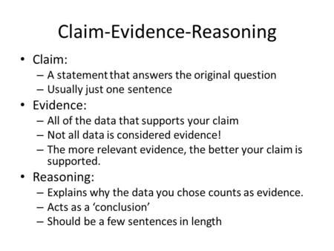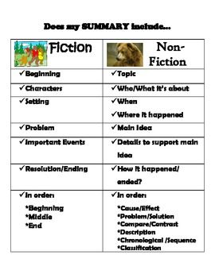
Paraphrase: a restatement of the meaning of a text or passage using other words. The term itself is derived via Latin from Greek, meaning "additional manner of expression". The act of paraphrasing is also called "paraphrasis".
Direct Quotations: a direct quotation reproduces the words of another writer verbatim and is displayed in quotation marks.

