Part 2. Human Impact on Environment - Aspects that Change the Face of Earth

These 5 charts explore the human impact on extreme weather

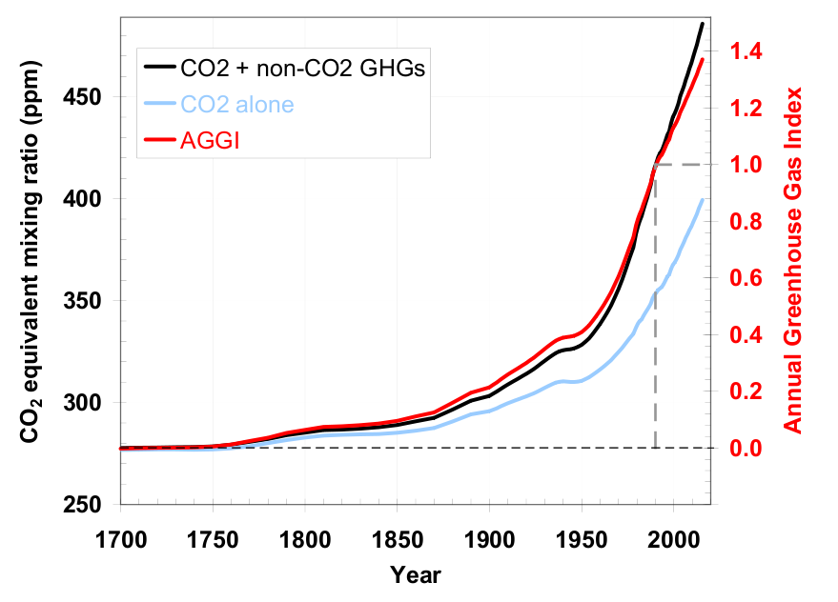
The chart, which was produced by NASA, shows the level of atmospheric carbon dioxide –– over the past years.
All kinds of human activities — from powering steam engines or driving a car to air conditioning a house or surfing the World Wide Web — have added release of enormous amounts of heat-absorbing gases into the atmosphere like Carbon dioxide or CO2, Methane or CH4, Nitrous oxide or N2O, Chlorofluorocarbons (also called CFCs, manufactured by industry for use in coolants and insulation) called the greenhouse gases.
The heat-trapping nature of gas has created a warming effect. (Green House Effect). This has coincided with an increase in the number and scale of natural disasters such as droughts, floods, wildfires and storms.
It will come as no surprise to learn that China and the United States are the largest carbon emitters. Both countries are among those with the biggest populations, the most factories and the highest number of cars.

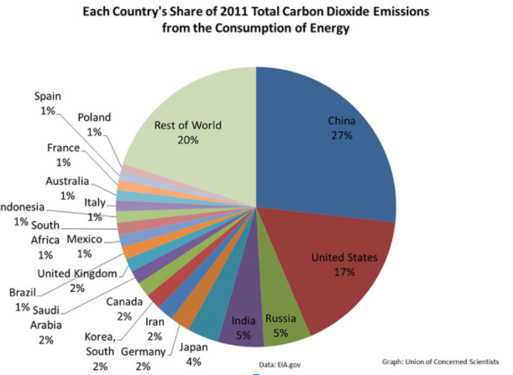

The planet’s average surface temperature has risen about 2.0 degrees Fahrenheit. Which in turn Effects the following -
Melting glaciers, caused Global sea level rise about 8 inches in the last century.
An increase in deaths due to heat stress.
A reduction in crop yields in most tropical and sub-tropical regions for most projected increases in temperature.
Decreased water availability for populations in many water-scarce areas.

The acidity of surface ocean waters has increased by about 30 percent.

What are the long-term effects of climate change?
Scientists have predicted that include a decrease in sea ice and an increase in permafrost thawing, an increase in heat waves and heavy precipitation, and decreased water resources in semi-arid regions.
According to the United Nations Office for Disaster Risk Reduction (UNISDR), China, the US and India were among the countries worst hit by extreme weather events from 1995 to 2015.
How can climate change affect natural disasters?
With increasing global surface temperatures, the possibility of more droughts and increased intensity of storms will likely occur. As more water vapor is evaporated into the atmosphere it becomes fuel for more powerful storms to develop. More heat in the atmosphere and warmer ocean surface temperatures can lead to increased wind speeds in tropical storms. Rising sea levels expose higher locations not usually subjected to the power of the sea and to the erosive forces of waves and currents. The result is worse flooding. Higher sea levels in turn lead to bigger storm surges, such as those that have caused devastation in Texas and southern China.
It’s no coincidence that an increase in carbon emissions coincides with a steady rise in the number of hydrological disasters over recent years. Some of the most prominent adverse effects could include
A greater risk of flooding for many communities, due to heavier rainfall from more intense storms as well as rising sea levels as polar ice caps melt
An increase in the number of people exposed to vector-borne (e.g., malaria) and water-borne (e.g., cholera) diseases due to changes in temperature and precipitation patterns

Other Aspects that Change the Face of Earth
Despite our tendency to consider Earth as static, it is actually a dynamic and ever-changing planet. Wind, water, and ice erode and shape the land. Volcanic activity and earthquakes alter the landscape in a dramatic and often violent manner. And on a much longer timescale, the movement of earth’s plates slowly reconfigures oceans and continents.
There are basically 2 types of changes that occur to the earth’s surface (i) Slow change and (ii) fast change. Fast changes occur through the actions of Earthquakes, volcanoes, landslides, etc. while slow change takes time and has a process like Weathering and Erosion.
Rainfall (water from the cloud) falls carrying out two major actions, firstly, it dissolves chemicals in the atmosphere and this solution causes chemical reactions on the various surfaces it falls on thereby weakening those surfaces through this action and secondly, by its impact on it wears off the surface. This second action becomes more vivid when you study the impact of a drop of water on a sandy surface. The impact dislodges the soils particles from others.
When there is significant amount of rainfall it leads to runoff (water running on the surface) and this runoff has enough force to move loose soil and rick particles to be deposited at a new location. The movement of these particles causes wear and tear on the surface on which they are moved and over time a new landscape evolves.
https://www.nationalgeographic.com/environment/natural-disasters/floods/#/11_venice_gettyimages-1055142968.jpg
https://www.nationalgeographic.com/environment/natural-disasters/floods/
Wind action follows a an almost similar pattern that is the wind carries particles into the air and those particles are not smooth but ragged in nature therefore as the wind currents drags them and often times slam them against surfaces, they tend to wear down the surfaces they come in contact with yielding a new landscape over time.
In Antarctica, katabatic winds play a large role in erosion. This type of wind occurs when high-density cold air builds up at high elevations (on the ice sheets, for example) and moves downhill under the force of gravity.

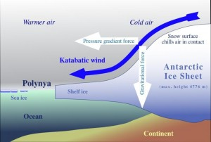
https://www.youtube.com/watch?v=eyjHpbYiRs4
https://www.youtube.com/watch?v=uBqohRu2RRk
Image courtesy of Hannes Grobe, Alfred Wegner Institute for Polar and Marine Research (Wikimedia).
Katabatic winds in Antarctica and Greenland are intensely cold and fast, often reaching hurricane speed. The winds in Antarctica carry small grains of sand that scour and erode the exposed rocks, resulting in unusual shapes and formations. These oddly shaped, eroded rocks are called ventifacts.

GLACIERS

Melting glaciers are caused by man-made global warming, study shows. Scientists rule out natural causes for rapid melting

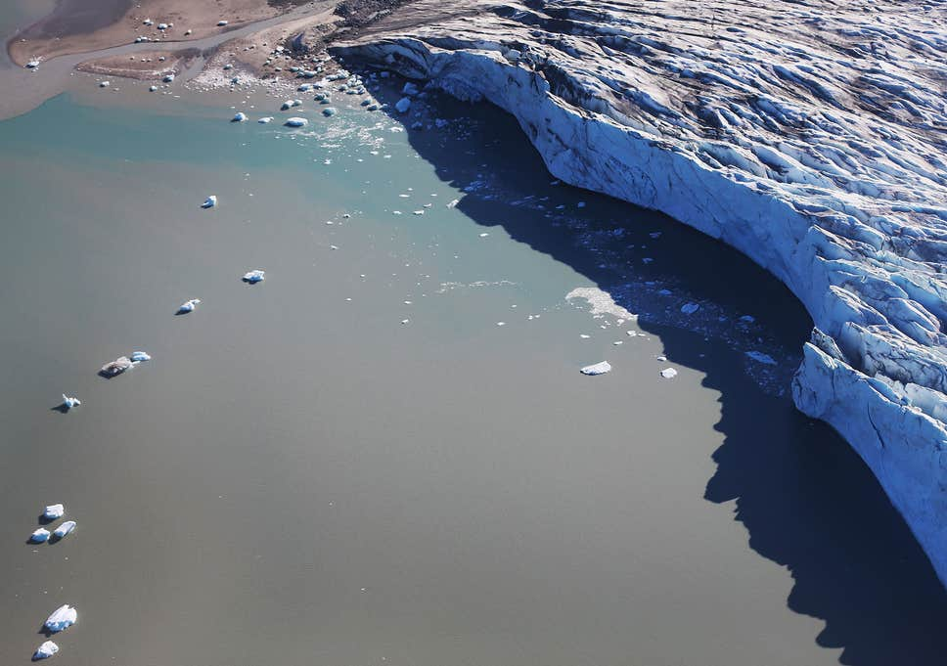
Research has found that two thirds of the current rate of glacial melting is due to human influences on the climate ( Getty Images )
The dramatic melting of the world’s mountain glaciers – from the Alps to the Himalayas – is mostly the result of man-made global warming rather than natural variability in the climate, a study has found.

Scientists have laid to rest the idea that glaciers as far apart as Patagonia and Indonesia are melting primarily because of natural changes to the climate.
An assessment of about 200,000 glaciers in the world, some of which have been monitored since the mid-19th century, has found that about two thirds of the current rate of glacial melting is due to human influences on the climate primarily caused by global warming resulting from industrial greenhouse gases.

The study found that about 25 per cent of the global loss of glacier ice that occurred between 1851 and 2010 could be attributable to human influences, but that this rose to about 69 per cent between 1991 and 2010, based on computer simulations of the climate that included natural and man-made effects.
Although mountain glaciers store less than one per cent of the total ice on earth, they are a major cause of global sea-level rise over the 20th century because they have melted so rapidly. The smaller glaciers of the Alps and Rocky Mountains are among the fastest disappearing masses of non-polar ice.
https://www.nytimes.com/interactive/2019/04/16/climate/glaciers-melting-alaska-washington.html

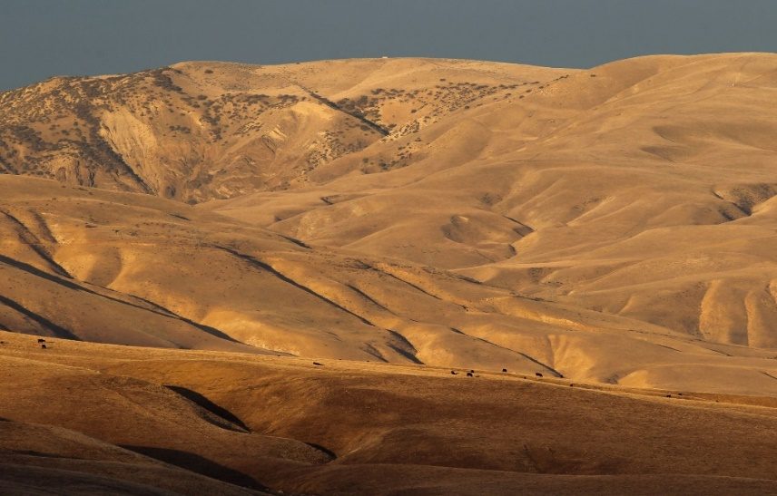
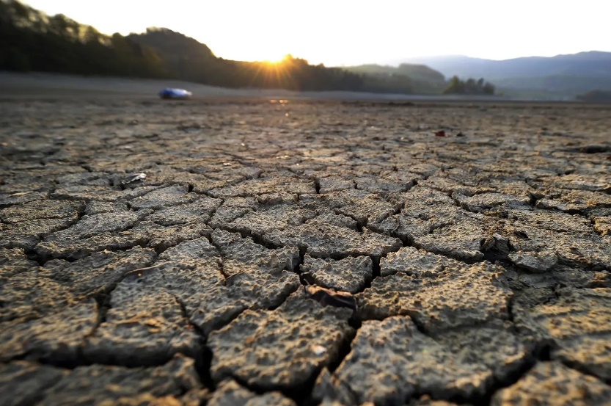
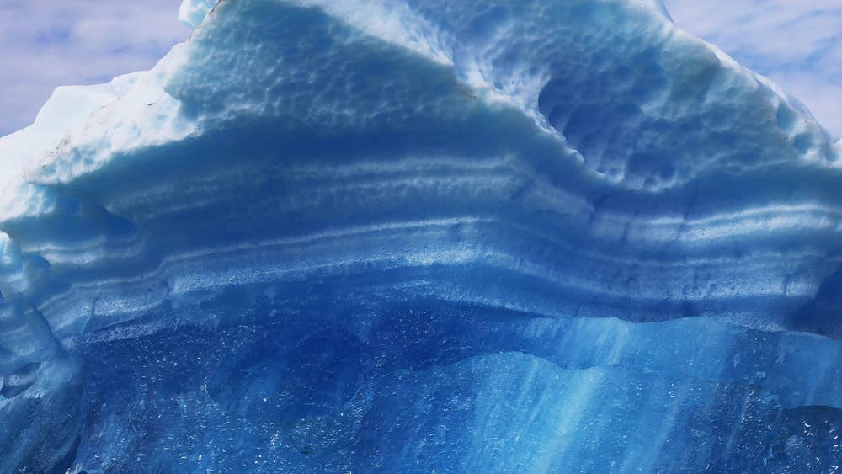
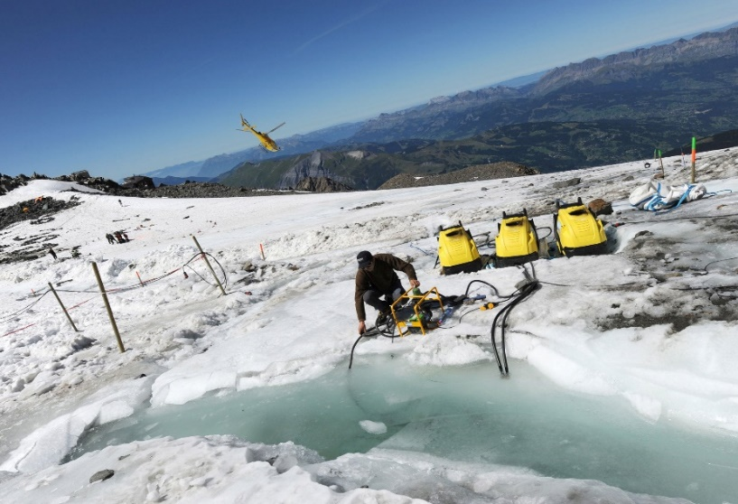
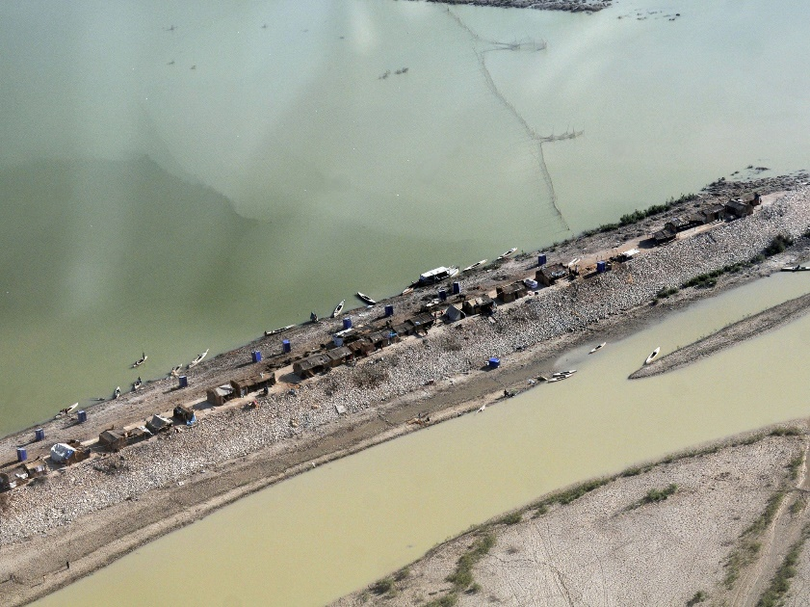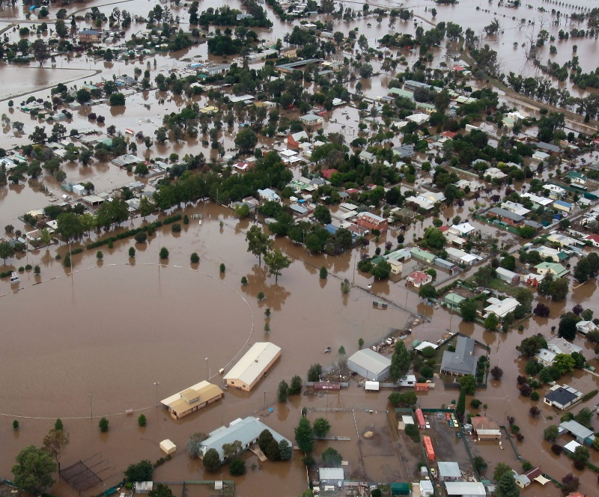
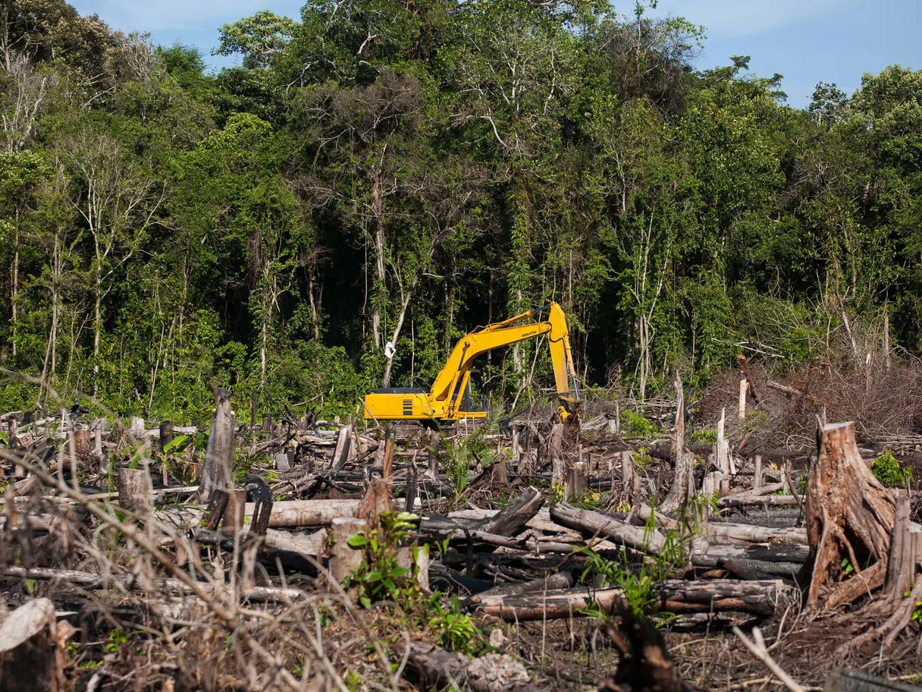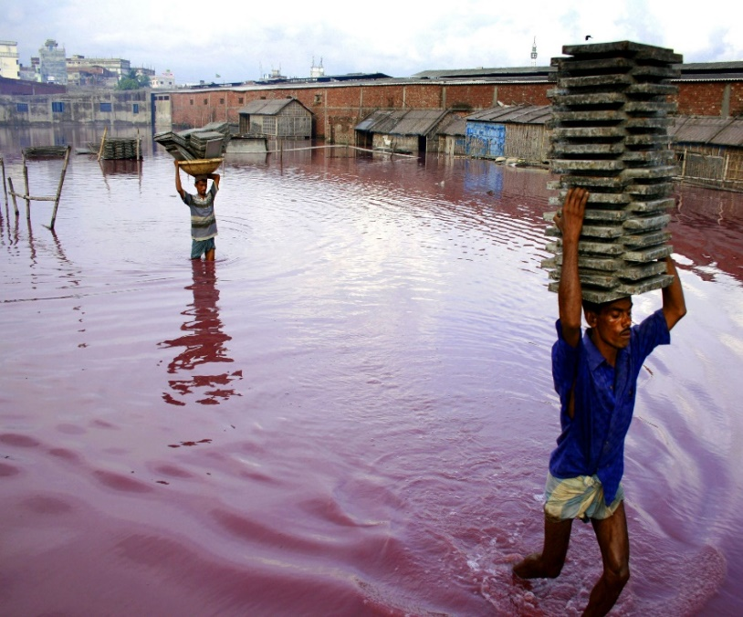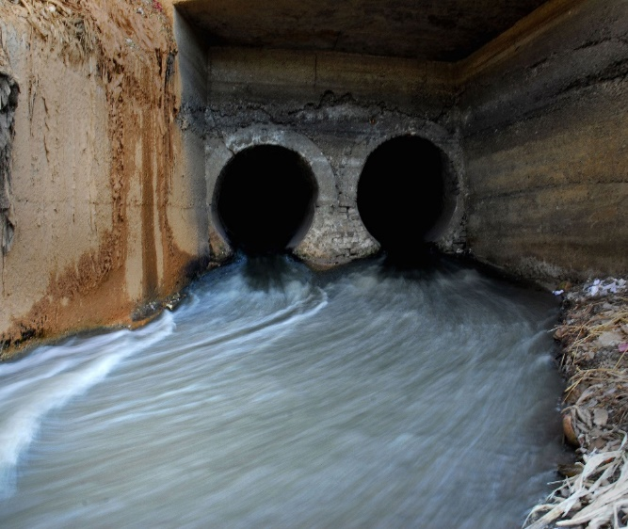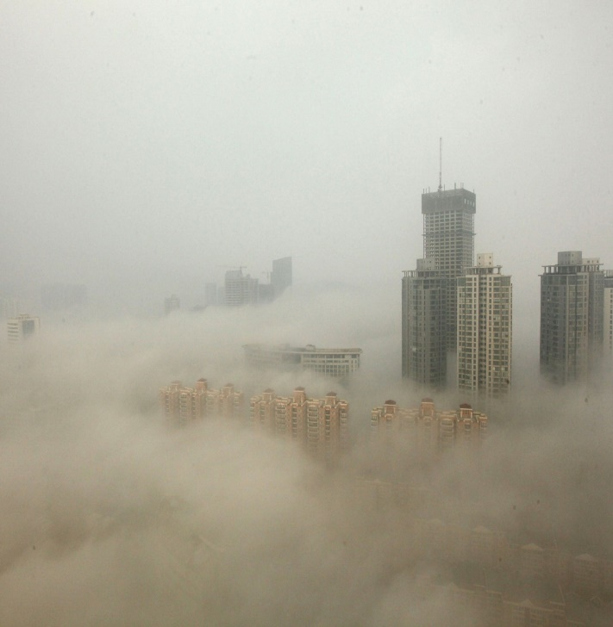

PLATE TECTONICS
The theory of plate tectonics describes the motions of earth’s lithosphere, or outermost layer of hard, solid rock, over geologic time.

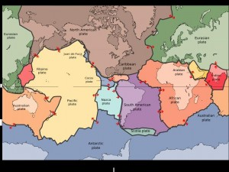
Tectonic plates. Image courtesy of Wikimedia.
Earth’s lithosphere is broken into seven major and many minor tectonic plates. These plates move in relation to each other, slowly changing the location of earth’s continents and oceans.
The movement of the tectonic plates are associated with much of the world’s volcanic and seismic activity.

VOLCANOES
A volcano is simply an area where magma, or molten rock, from the earth’s mantle reaches the earth’s surface, becoming lava. Most volcanoes occur at plate boundaries, where two plates are moving away (diverging) or together (converging). A few volcanoes like the Hawaiian Islands form from a hot spot, or a weak spot in earth’s crust, where magma forces its way to the surface.
Volcanic eruptions may be explosive (violent) or effusive (passive), depending on the lava chemistry (amounts of silica and dissolved gases). Silica is a mineral found in nature as sand or quartz. High levels of silica mean very viscous (thick) lava, and low levels mean more fluid lava. Dissolved gases build up inside the volcano, much like a can of soda or another carbonated beverage. The higher the level of gas, the more pressure that builds – and the more violent an explosion. The combination of silica and dissolved gas levels determines the type of eruption and shape of the volcano. Largely unexplored, the Gakkel Ridge runs underneath the Arctic Ocean. Scientists have discovered volcanic craters and evidence of surprisingly violent eruptions in the recent past.

The summit of Mt. Erebus from the front seat of a helicopter. Photo courtesy of Mt. Erebus Volcano Observatory.
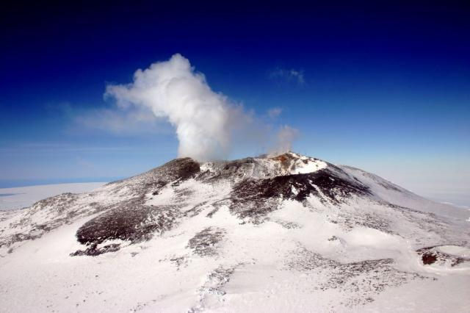

Earth Quakes:
An earthquake (also known as a quake, tremor or temblor) is the shaking of the surface of the Earth resulting from a sudden release of energy in the Earth's lithosphere that creates seismic waves. ... The word tremor is also used for non-earthquake. Seismic activity (earthquakes) is most often associated with tectonic plate boundaries. As plates slowly move, their jagged edges stick and suddenly slip, causing an earthquake.
The Gakkel Ridge underneath the Arctic Ocean experiences small earthquakes that accompany the volcanic activity found in the area. Antarctica, which lies in the center of a tectonic plate, does not experience many earthquakes. However, seismic activity is associated with eruptions of Mt. Erebus.
https://www.youtube.com/watch?v=DJmYBTnUjSY
https://www.youtube.com/watch?v=FIgksa3x11w
https://www.youtube.com/watch?v=AArne-wh_Uc&feature=youtu.be
https://www.youtube.com/watch?v=Hoivmphn9A8&feature=youtu.be
What Causes Landslides?
Landslides can be initiated in slopes already on the verge of movement by rainfall, snowmelt, changes in water level, stream erosion, changes in ground water, earthquakes, volcanic activity, disturbance by human activities, or any combination of these factors.
Human activity, such as agriculture and construction, can increase the risk of a landslide. Irrigation, deforestation, excavation, and water leakage are some of the common activities that can help destabilize, or weaken, a slope.
To prevent Landslides:
1. Maintain as much vegetation as possible on the slope to help retain the soil.
3. Do not add additional water from downspouts to slopes from storm water runoff being directed to a hillside.
4. Do not have an irrigation system on a hillside.
Watch Videos by clicking Link given below:-
https://trapbag.com/mudslide-protection?gclid=CjwKCAjwpqv0BRABEiwA-TySweyLHhNvcor1nZcpLrm48EDL9lxBB5AgK7hz1Y-_3b4Bn2TNzkfb0BoCbFwQAvD_BwE
https://www.youtube.com/watch?v=dj44dpr8oHs
https://www.youtube.com/watch?v=HiNwmj5ALZs
Forest Fire: Depends on three factors Fuel, Weather and Topography
Fuel: There are three elements that are required for a forest fire to burn: Heat, Oxygen, and Fuel (wood). This is the so-called "fire triangle".
Weather: Fires are much more likely to start and spread during droughts when the grass and plants are dry and the temperature is high.
Causes: Human Activity: Nearly 85 percent* of wildland fires in the United States are caused by humans. Human-caused fires result from campfires left unattended, the burning of debris, equipment use and malfunctions, negligently discarded cigarettes, and intentional acts of arson.
Natural: Most of Natural Fires result from Lightning. Other natural causes include volcanic eruptions and sparks from falling rocks.
How to prevent a wildfire?
- First step Contact 911, your local fire department, or the park service if you notice an unattended or out-of-control fire.
- Never leave a fire unattended.
- Do not discard cigarettes, matches, and smoking materials from moving vehicles, or anywhere on park grounds.
- Follow local ordinances when burning yard waste. Avoid backyard burning in windy conditions, and keep a shovel, water, and fire retardant nearby to keep fires in check. Remove all flammables from the yard when burning.
Video Links for better learning: -
https://www.youtube.com/watch?v=noJuE3oP2II
https://www.nationalgeographic.com/environment/natural-disasters/wildfire-safety-tips/
What is a tornado?
A tornado is a narrow, violently rotating column of air that extends from a thunderstorm to the ground. Because wind is invisible, it is hard to see a tornado unless it forms a condensation funnel made up of water droplets, dust and debris. Tornadoes can be among the most violent phenomena of all atmospheric storms we experience.
Where do tornadoes occur?
Tornadoes occur in many parts of the world, including Australia, Europe, Africa, Asia, and South America. Even New Zealand reports about 20 tornadoes each year. Two of the highest concentrations of tornadoes outside the U.S. are Argentina and Bangladesh.
How many tornadoes occur in the U.S. each year?
About 1,200 tornadoes hit the U.S. yearly. high tornado occurrence in the central part of United States.
When are tornadoes most likely?
Tornado season usually refers to the time of year the U.S. sees the most tornadoes. The peak “tornado season” for the southern Plains (e.g., Texas, Oklahoma, and Kansas) is from May into early June. On the Gulf coast, it is earlier in the spring. In the northern Plains and upper Midwest (North and South Dakota, Nebraska, Iowa, Minnesota), tornado season is in June or July. But, remember, tornadoes can happen at any time of year. Tornadoes can also happen at any time of day or night, but most tornadoes occur between 4–9 p.m.
Blizzards are dangerous winter storms that are a combination of blowing snow and wind resulting in very low visibilities. While heavy snowfalls and severe cold often accompany blizzards. Most precipitation that forms in wintertime clouds starts out as snow because the top layer of the storm is usually cold enough to create snowflakes. Snowflakes are just collections of ice crystals that cling to each other as they fall toward the ground. Precipitation continues to fall as snow when the temperature remains at or below 0 degrees Celsius from the cloud base to the ground.
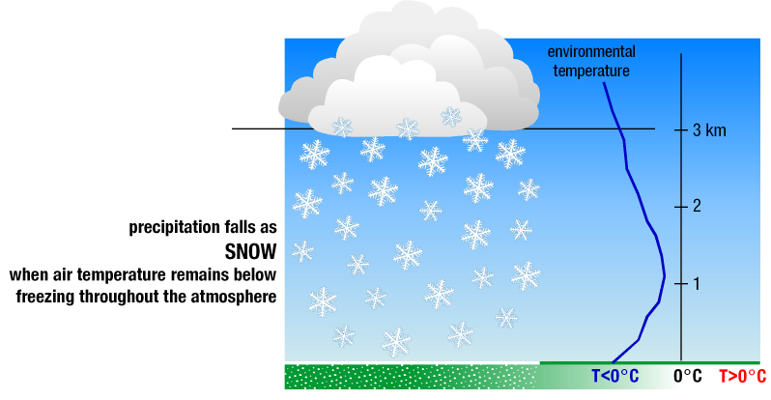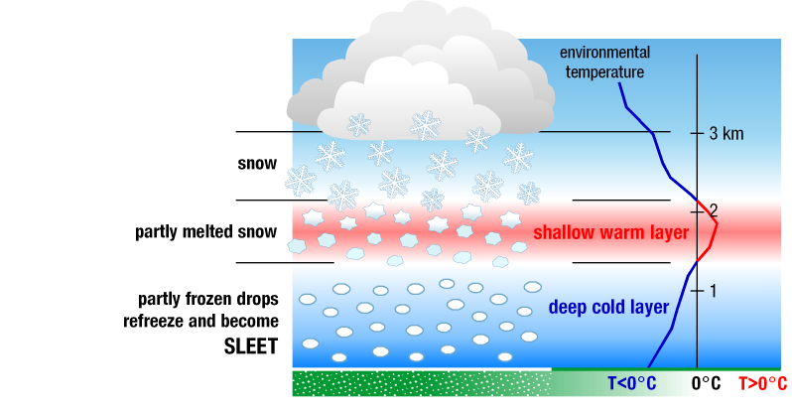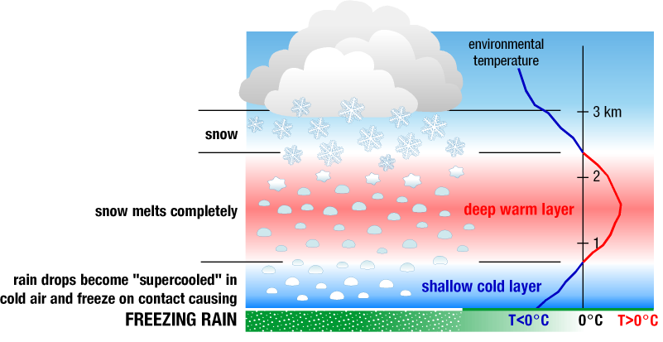

Part 2 Week 2 Human Impact on Environment
Section.1 Check for understanding.
Answer all the questions given below. Each question carries (weightage) 5 points.
- Name some of the gases, which are emitted from Cars, Air conditioners and Computers.
- From the line graph chart given out by NASA, compare the amount of Carbon Di Oxide present in Air from the year 1950 to the year 2000.
- From the pie chart, compare the amount of carbon di oxide given out by China VS USA Vs India.
- How does heat get trapped within Earth’s Atmosphere?
- Relate the concept climate change to natural disasters?
- How did climate change effect the glaciers and Sea level?
- What are Tectonic plates? How does their movement effect the Environment?
- Why does molten lava/ Volcano erupt?
- What is an Earth Quake?
- List some causes of Land Slides?
- What are the three elements that can cause a Forest Fire?
- List the human activity that can cause a forest fire and what preventions are recommended to avoid forest fire?
- What is a tornado?
- Differentiate the formation of Sleet, Snow and Freezing Rain.

Section 2. Fill Up the Blanks with correct word/term after reading the lesson. Each Correct Response has a weightage of 1 point.
Vocabulary words
Carbon-di-oxide- methane -Nitrous Oxide-Chlorofluorocarbons, heat holding, 2%, 30%, Plate tectonics, Volcano,
Earth Quake, Landslide, Heat-Oxygen-Fuel, Tornado, Blizzard.
- The planet’s average surface temperature has risen about ______________ Fahrenheit.
- The ______________________ nature of gas has created a warming effect.
- Greenhouse gases are ________________________, _________________________, _______________________________ and _________________________________.
- The acidity of surface ocean waters has increased by about __________ percent.
- Earth’s lithosphere is broken into seven major and many minor ___________ __________.
- A ___________________ is simply an area where magma, or molten rock, from the earth’s mantle reaches the earth’s surface.
- An ________________ is the shaking of the surface of the Earth resulting from a sudden release of energy in the Earth's lithosphere.
- Human activity, such as agriculture and construction, can increase the risk of a _____________________.
- The three elements that are required for a forest fire to burn: _________________, ________________ and ________________________.
- A ____________________is a narrow, violently rotating column of air that extends from a thunderstorm to the ground.
- ___________________ are dangerous winter storms that are a combination of blowing snow and wind resulting in very low visibilities.

Section 3: Matching Activity
Match the Terms with the correct definitions. Each correct response has a weightage of 1 point
Terms | Definitions
- Flood | - vibration from underground movement along a fault plane
- Forest Fire | - the process of wearing or grinding something down
- Dam | - the rising of a body of water and its overflowing onto land
- Erosion | - an uncontrolled fire in a wooded area
- Earth Quake | - a fissure in the earth's crust through which gases erupt
- Lightning | - air moving from high pressure to low pressure
- magma | - a storm resulting from strong rising air currents
- Thunderstorm | - molten rock in the earth's crust
- Volcano | - flash of light from an electric discharge in the atmosphere
- Wind | - a barrier constructed to contain the flow of water
- Blizzard | - A narrow, violently rotating column of air that extends from a thunderstorm to the ground.
- Tornado | - dangerous winter storms that are a combination of blowing snow and wind resulting in very low visibilities

