6th Grade Math Review

Name: ___________________________
- $\frac{5}{8}$ ÷ $\frac{3}{4}$= | - How would you write the following phrase as a number expression?  Seven more than c
- Which shows 24 + 54 written using the GCF and the distributive property?  - 12(2 + 4)  - 6(4 + 9)  - 2(12 + 27)  - 3(8 + 51) | - Which is the lower rate?  165 students on 5 buses  or  140 students on 4 buses
- Which point is located at (-2, -4)?  Which point is located at (5, -1)? | - Find the unit rate.  294 miles every 14 gallons
- $\frac{3}{5}$ ÷ $\frac{9}{12}$= | - How would you write the following phrase as a number expression?  eight more than double a number
- The length of a swimming pool is 4 feet shorter than triple the width. Let n represent the width. Which expression gives the length of the swimming pool?  - 3n – 4  - 3n + 4  - 3(n – 4)  - 3(n + 4) | - Solve this expression  (9-3) x 7
- What are the coordinate points for D?  What are the coordinate points for B? | - Find the unit rate.  $1.96 for 4 pounds of bananas
- $\frac{9}{10}$ ÷ $\frac{3}{5}$= | - Which statement represents the expression 3r – 5?  - The product of 3 and a number less than 5  - 5 minus the product of 3 and a number  - 5 less than the product of 3 and a number  - The product of 3 and a number subtracted from 5
- How would you write the following phrase as a number expression:  twelve more than the quotient of a number and five | - Evaluate the following:  18 divided by y,  where y = 2.
- What is the algebraic expression for the product of 12 and a number? | - Evaluate the following expression:  4b + c  Where b=8 and c=6
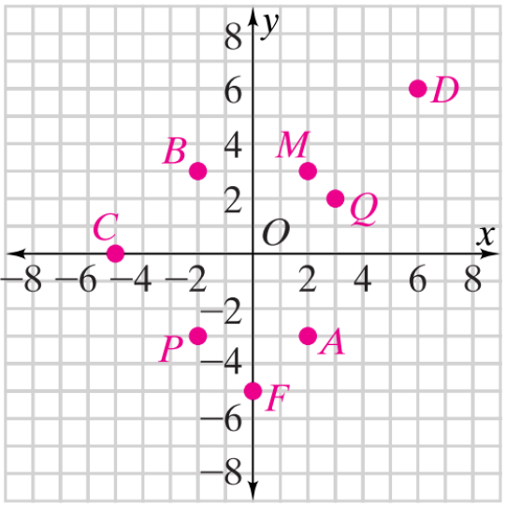
- A. What are the coordinates for point P?

B. What are the coordinates for point B?

C. What are the coordinates for point F?

