11.5 : Angle-Angle Triangle similarity

Essential Question: How can you use angle relationships to decide whether two triangles are similar?

Vocabulary:

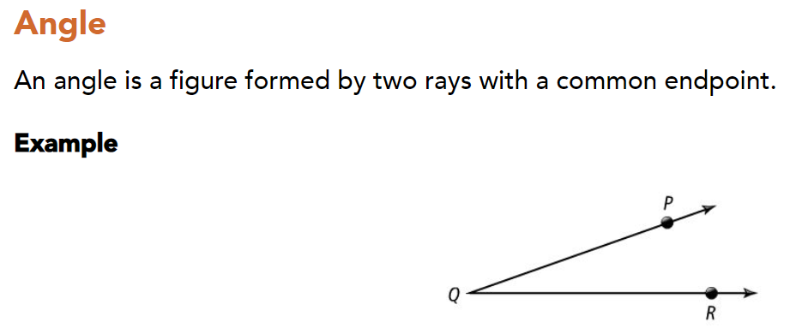

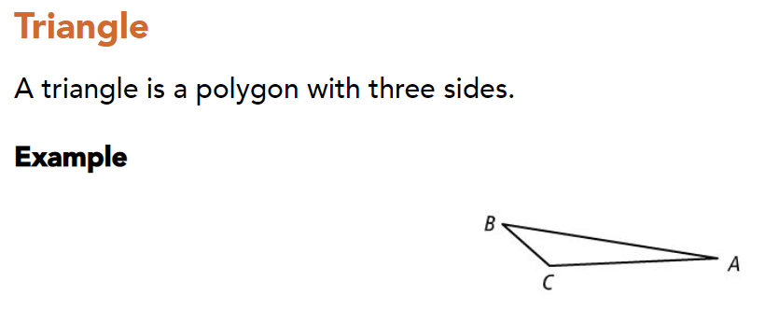

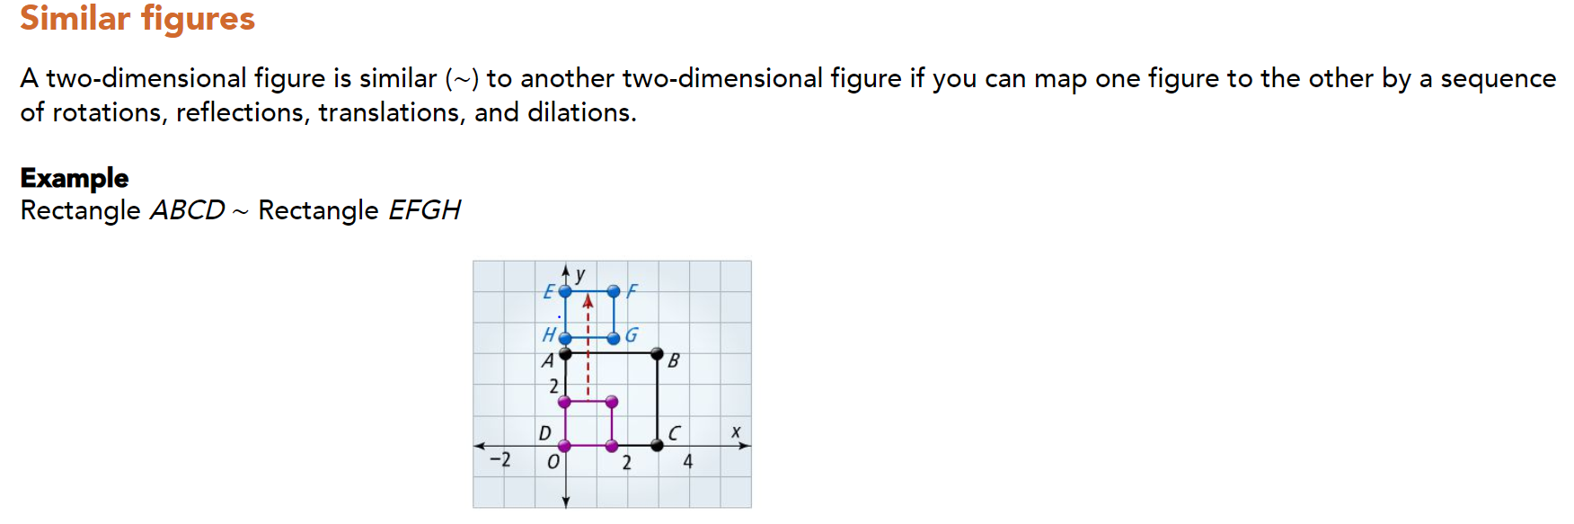

Notes:

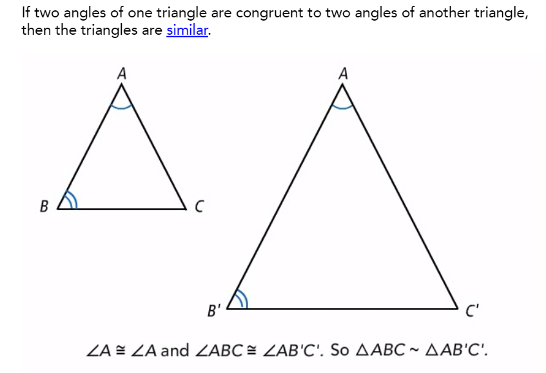

Part1:

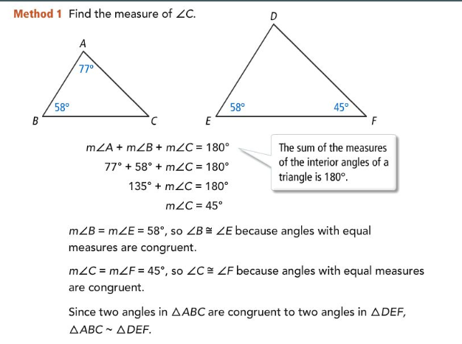

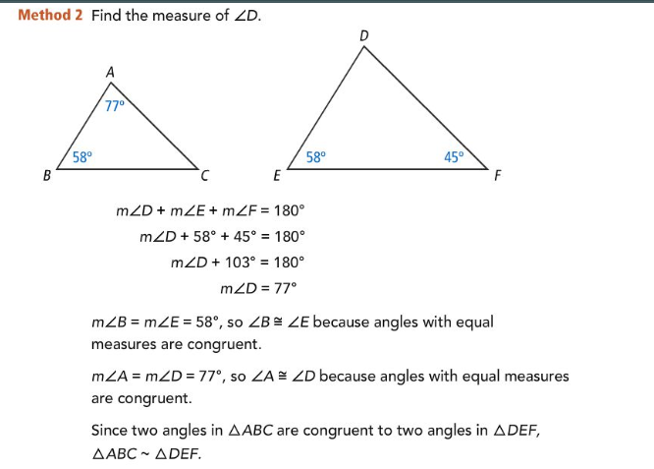

Try:

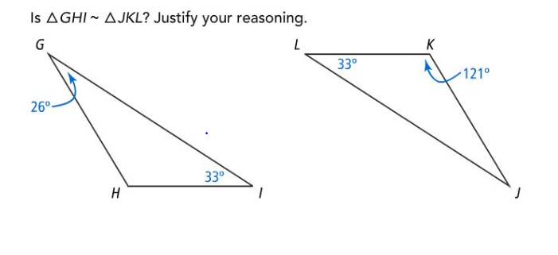Answer:__________

Part2:

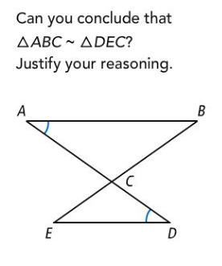

Solution: 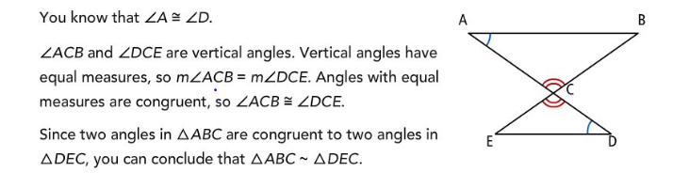

Try:

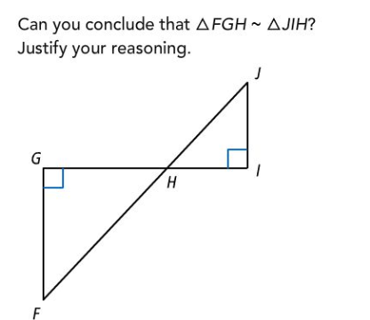Answer:_______________________

Part3:

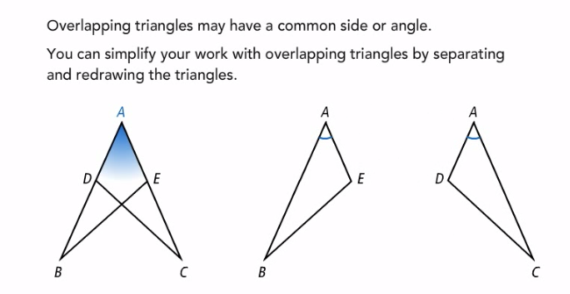

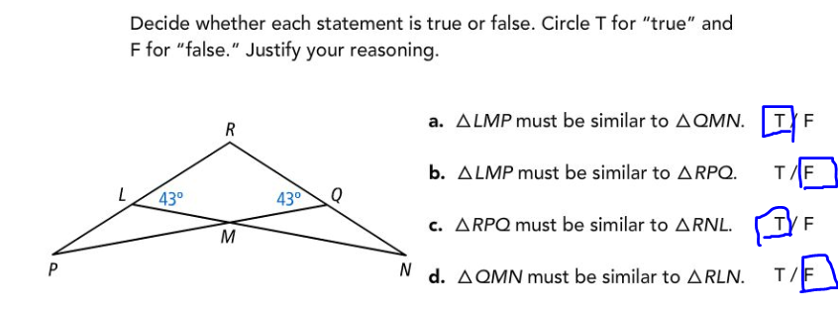

Try:

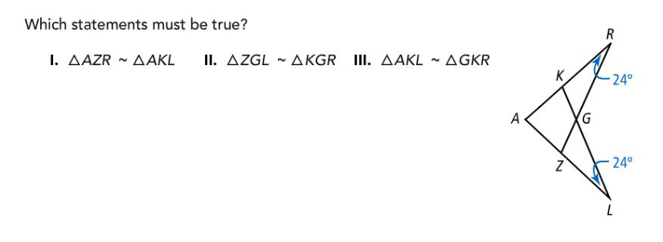Answer:_________________

Summary:

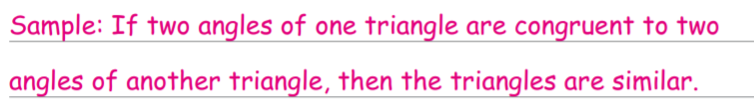

Answers

Part1 Try:

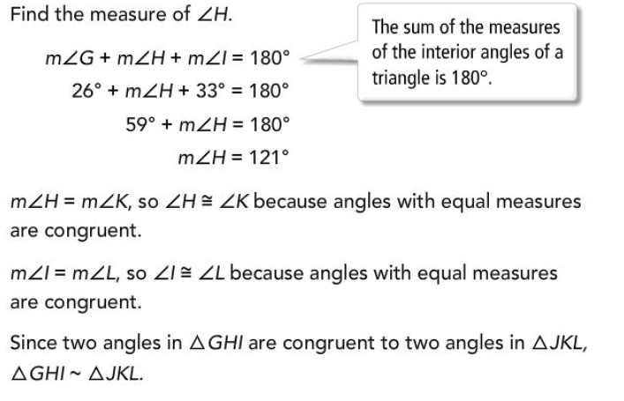

Part2 Try:

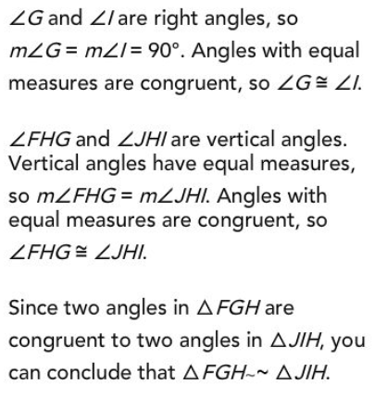

Part3 Try: I and II