11.4 Exterior Angles of Triangles
Essential Question: What is the relationship between the exterior and interior angles of a triangle?
Vocabulary:
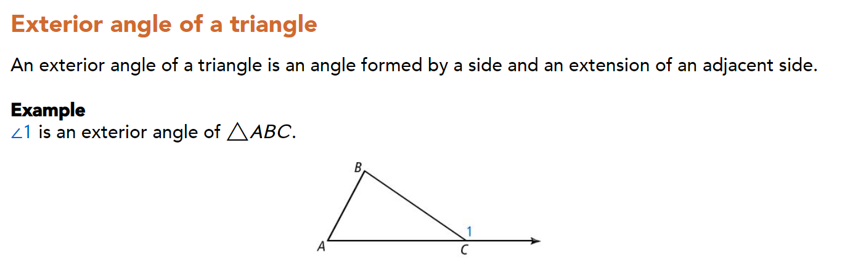
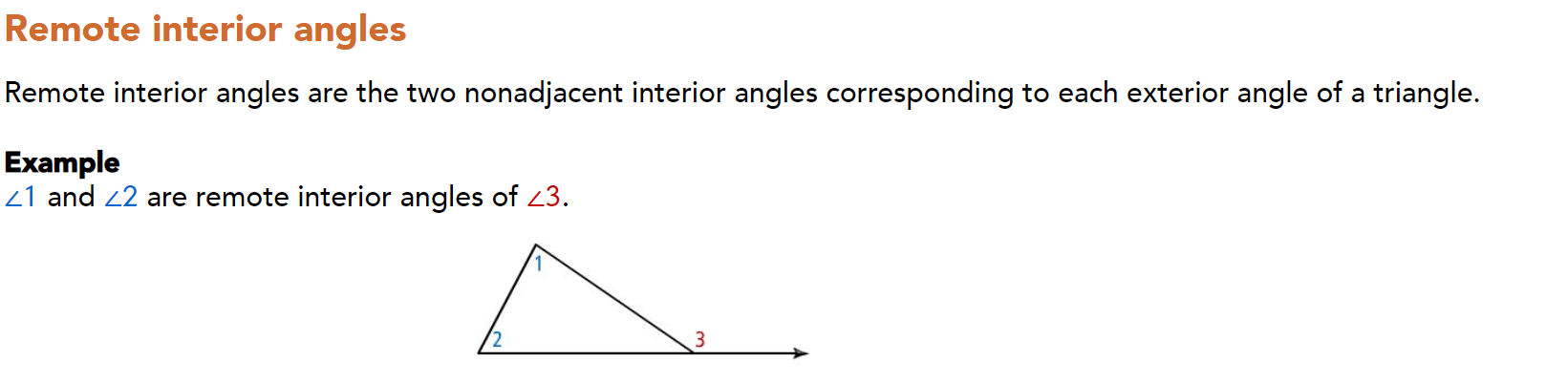
Notes:
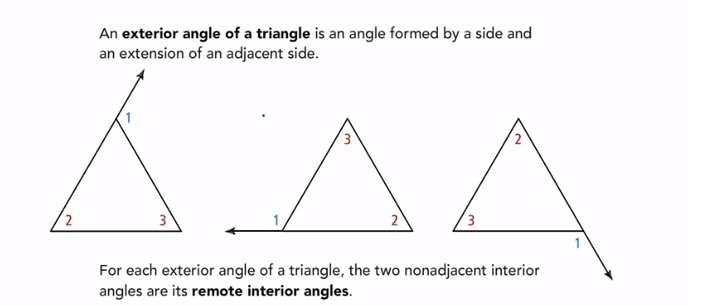
Try:
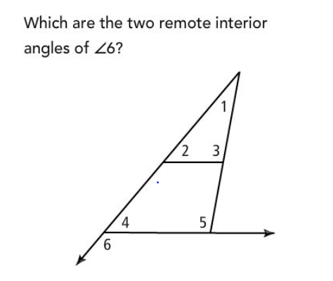Answer_______________
Key concept:
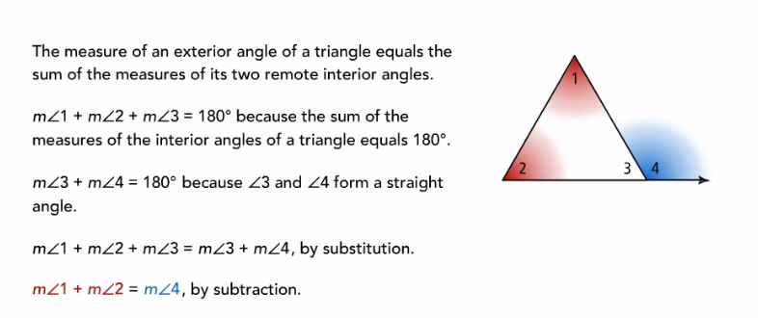
Part2:
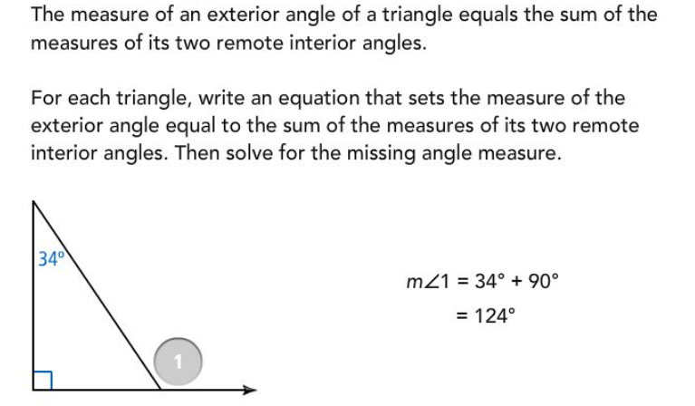
Try:
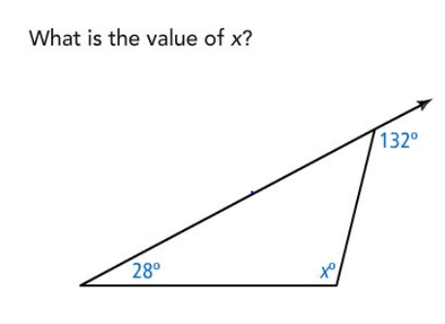

Part3:
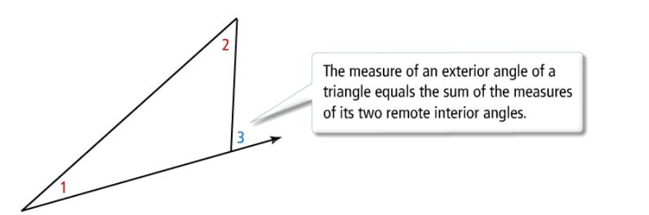
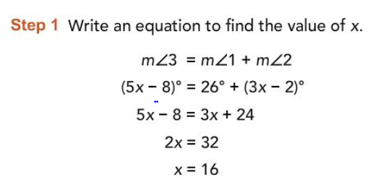
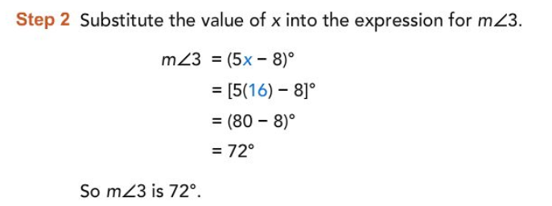
Try:
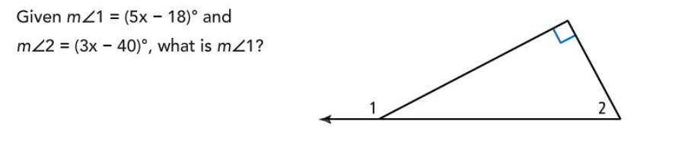 Answer__________________
Summary:
Answers: Part1 Try: Part2 Try: 104 Part3 Try: 152⁰

