Notes: 4.1 Exploring Scientific notation
Focus question: Why might you use powers of ten to write numbers?
Vocabulary:
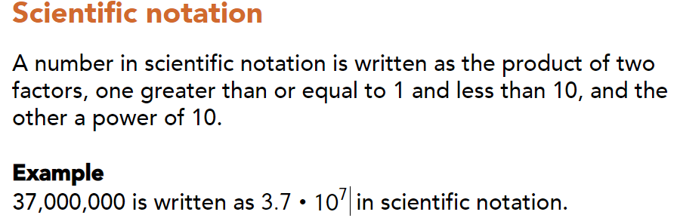
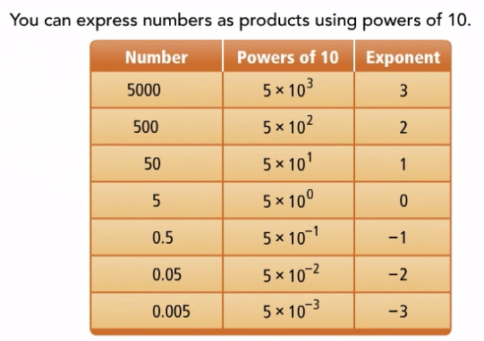

Part1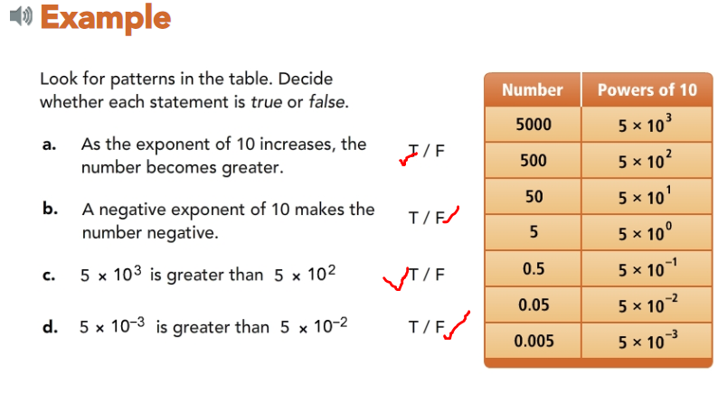
Part1Try:
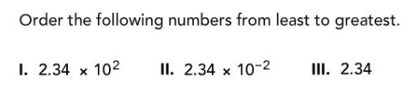
Key Concept:
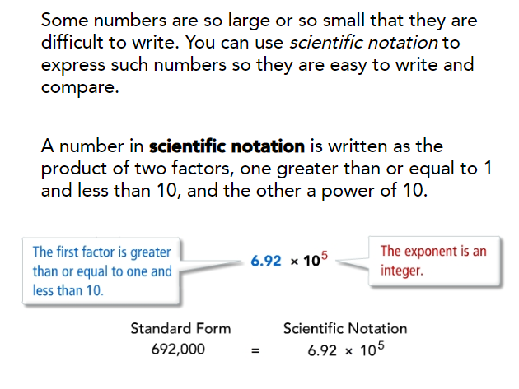
Part2:
Example:
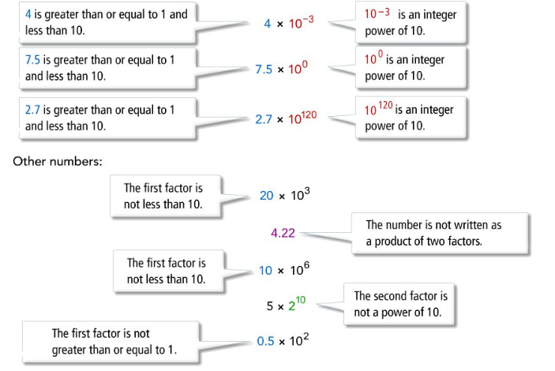

Part2 Try:
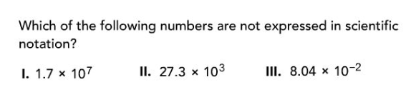
Part3:
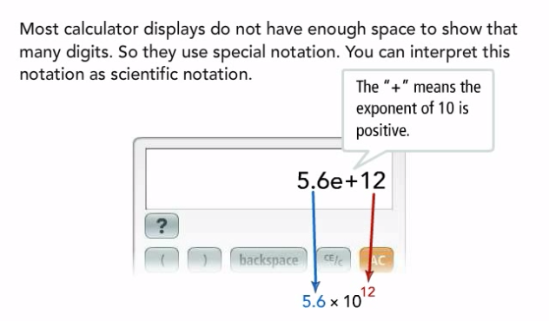
Example:
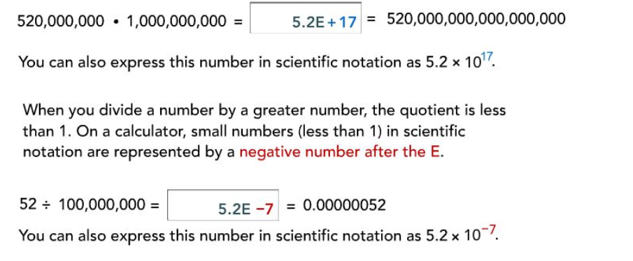
Part3Try:
Summary:
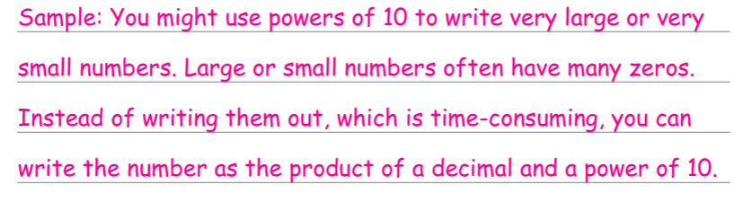
Answers:
Part1 Try:
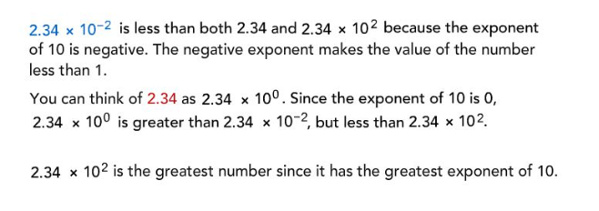
Part2 Try:
Part3 Try:
