Math, 1st Period, 4th Quarter 2019-2020, Ms. Angell, May 1st – May 8th
State Standards Focus: Statistics and Probability – Data Collection and Analysis

- Understand how data collection is based on specific types of questions.
- Know how to plot (record the data) in a variety of ways.
- Know how to find summarized values of the data.
- Describe how the data is distributed (variation in data collected).
- Use the data distribution and summary values to analyze the data to make conclusions.

This is a difficult but important unit –
Lots of students are interested in it; if not, well – brain growth time! Persevere!
This is information critical to science and engineering as well as business ventures.
I will score the work with a 15% bonus, so 85% is an A

The TED Ed Video is super important in real life!

Final Products

- TED Ed: Annotation, No summary How many ways can you arrange a deck of cards? - Yannay Khaikin

- Online Digits, show work only as needed, 85 % curve = 100% :

- Digits Online: Topic 15 Review Lesson Background – vocab, pull it together, topic close
- Digits Online: Topic 15 Topic Review
- Digits Online: Topic 16 readiness lesson background
- Digits Online: Topic 16 r16 Homework
- Digits Online: Topic 16 -1 lesson background
- Digits Online: Topic 16 – 1 16G homework

- TED Ed How many ways can you arrange a deck of cards? - Yannay Khaikin
- Watch!
- Respond: - 5 facts, 2 comments, 2 questions, 2 ahas

Bonus question – create a diagram of a factorial!

- Digits Tasks:

- Background Tasks are the Lesson on line – Topic Opener, Launch, Key Concepts, Parts, Close and Check, all similar to the workbook.
- You can do this! And remember, on the “G” tasks, 85% = 100%, 75% = 90%, 65% = 80… YAY!
- Mixed Reviews need 100%!
- Carefully follow the Lesson Background before doing the “G”
- Glossary for Vocabulary will be very helpful.
- “Show Me an Example” drop downs – USE THEM!

Grading:
- Digits: 85% curve! Video: regular rubric.
- turning in product: turned into Williams, or photographed and sent to cangell@tusd.net

Questions: cangell@tusd.net Email anytime of course, but online hours I will be actively replying in real time will be 11am - 1:00pm (and checking email frequently)
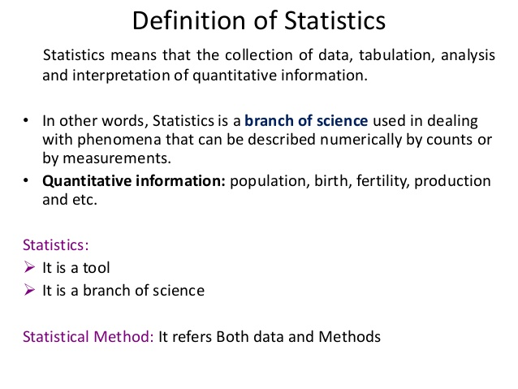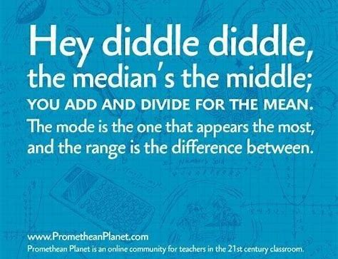
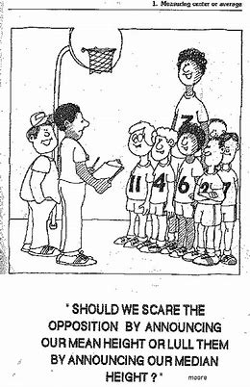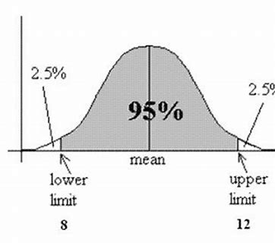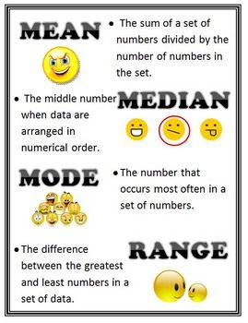
This will make sense soon! The one kid is an outlier, which affects the measures used to describe the data set.

