History, 4th Period, 4th Quarter 2019-2020, Ms. Angell, May 4th – May 8th
State Standards Focus:
- city states and geography relationship in terms of development and trade
- cause effect - the change from tyranny to oligarchy to democracy
- Athenian direct democracy versus representative democracy
- Significance of Greek mythology to the ancient Greeks and to modern society
- Founding, expansion and political organization of the Persian Empire
- The rise of Alexander the Great and the spread of Greek culture
- Science and Arts influences/contributions: Hypatia, Socrates, Plato, Aristotle, Euclid, Thucydides

Wow! A lot to cover, so we will be integrating some of these in Language Arts over the next few weeks

Overview: Final Products for Standards

- Factoid Poster Alexander the Great
- Factoid Poster Persian Empire
- Venn Diagram Persian Empire to Alexander’s Empire
- Icon List Spread of Greek Culture
- Greek Legacy – Content Paragraph

Detailed Tasks Aligned to Standards and Online Suggested Sources

- Factoid Poster Alexander the Great

https://www.ducksters.com/biography/alexander_the_great.php

Include: title, subtitle, caption (summary statement), 7 facts, one diagram/illustration, and 3 key vocabulary words in a word bank. Color as needed for clarification or emphasis only.

- Factoid Poster Persian Empire

https://www.ducksters.com/history/mesopotamia/persian_empire.php
and read the attached Document A below from Mr. Donn

Include: title, subtitle, caption (summary statement), 7 facts, one diagram/illustration, and 3 key vocabulary words in a word bank. Color as needed for clarification or emphasis only.

- Venn Diagram Persian Empire to Alexander’s Empire

Using the information from 1 and 2, and the timelines below for general reference, create a Venn diagram chart comparing the two empires – about 4 facts each area sufficient

- Icon List Spread of Greek Culture

Read the attached Document B below from Mr. Donn
And watch a Ancient Greece 101 | National Geographic

List 5 or more facts showing that Alexander the Great spread Greek Culture – include an icon with each.

Content Paragraph: Greek Legacy – review Ancient Greece 101 | National Geographic
Why is the Ancient Greek’s Civilization considered legendary?

Include basics: hook, background, thesis statement, 4+ facts supported with details, conclusion and AHA emphasizing thesis

Grading: regular rubric
turning in product: turned into Williams, or photographed and sent to cangell@tusd.net
Questions: cangell@tusd.net
Email anytime of course, but online hours I will be actively replying in real time will be 11am - 1:00pm (and checking email frequently)

Document A. The Origins and Impacts of the Persian Empire (Mr. Donn)

The origin of the Persian Empire can be attributed to the leadership of one
man—Cyrus the Great. A brilliant and powerful Persian king, Cyrus’ strategy
for enlarging the Persian kingdom was to conquer nearby lands and then
unite them into one empire.

Through his skillful leadership and a strong
military, Cyrus was able to create a vast empire that would last for more
than two hundred years. The origins and impacts of Cyrus the Great’s empire
made it possible for the emperors who came after him, such as Darius I, to
continue to expand and control the Persian Empire.

A people called the Medes controlled the land that connects east and
west Asia. The land was called Media. In this land were small Persian
kingdoms. Around 550 B.C. Cyrus the Great, a Persian king, took control of
these lands from the Medes. He then formed a government and chose both
Median and Persian nobles to be civilian officials.

Next, Cyrus used his
strong military to attack states throughout Anatolia (Asia Minor). Soon this
region fell under his control. He went on to conquer the lands to the east
known as the Fertile Crescent. The Persian empire was now immense.
Cyrus was a skillful ruler. He adopted a policy of toleration toward the
people he conquered. For example, he allowed them to speak their own
languages, practice their own religions, and follow their own ways of life. He
also declared the first Charter of Human Rights. Etched on a clay cylinder,
this charter set forth Cyrus’ goals and policies. His respect for the people
made Cyrus popular and made it easier for him to create a peaceful and
stable empire.

After Cyrus’ death, there was a period of unrest under a weak emperor.
Then a strong emperor, Darius I, came to power. Building on what Cyrus had
achieved, Darius divided the Persian Empire into several provinces to make
it easier to govern. He appointed a governor called a satrap to carry out his
orders in each province and to collect taxes. Darius also started use of a
Royal Road that allowed messages, soldiers, and mail to be sent quickly
across the empire. He promoted trade and business and established a law
code. The Persian Empire would have a long life because of the efforts
of Darius.

Document B. Alexander's Legacy from penfield.ed (Mr. Donn)
- Alexander spread Greek culture throughout the Persian Empire, including parts of Asia and Africa. Alexander respected the local cultures he conquered, and allowed their customs to continue. Alexander himself embraced local customs, wearing Persian clothes and marrying Persian women. Alexander encouraged his soldiers to marry Persian women, in this way, the children of these marriages would share both Persian and Greek cultures.
- Alexander created the Hellenistic Age, a time when Greek culture mixed with the various cultures of Alexander's Empire. This was a time of advances in learning, math, art, and architecture. Some of the great names of learning in this Age include Archimedes, Hero, and Euclid. It was a time of relative peace. (The Hellenistic Age began with Alexander's death and ended about 200 years later when the Romans conquered the entire Mediterranean region.)
- Because of the relative peace during the Hellenistic Age, travel and trade increased. Antipater of the city of Sidon, created a poem around 140 BC that listed seven wonders of the world. Antipater picked these buildings and statues for there art and architecture. The list became a set of tourist attractions for people of the ancient world.
- The great cities of the Hellenistic Age included Antioch in Syria, Pergamum in Asia Minor, and Alexandria in Egypt, with its Library of Alexandria, the largest library of the ancient world. Although none of these cities were in Greece, they all had Greek architecture."

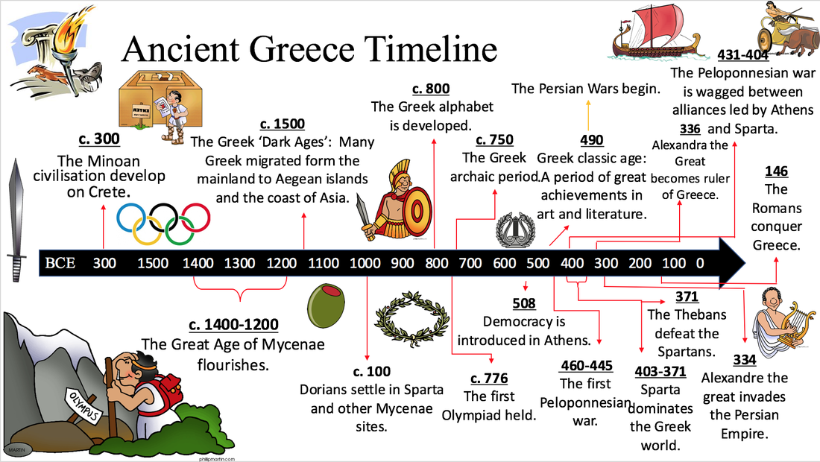

Ancient Persia – Simplified Timeline, the second half of it involved ongoing war with Greece!

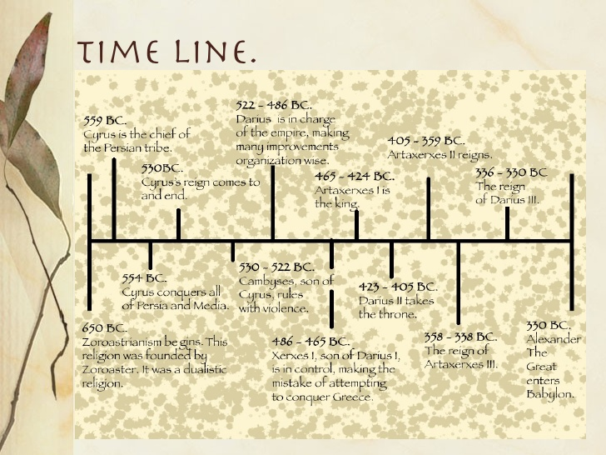

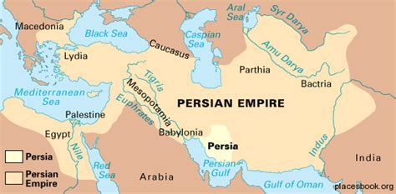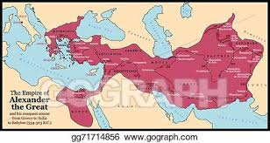
Persian Empire Alexander The Great Empire

