Afternoon Lab: Build a Solar Oven With Your Kids
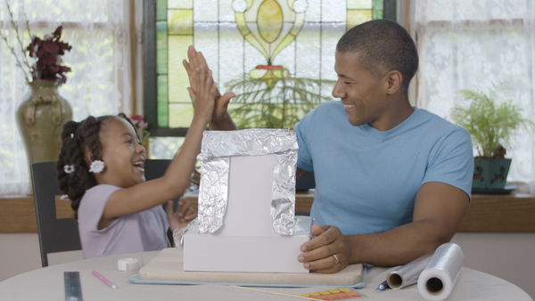
This story was produced in partnership with Lance® sandwich crackers, two awesomes with an incredible in between that has been made that way for 100 years.
The time between picking your kid up from school and right before dinner is precious. The handful of hours you have before you both hit the hay is a chunk of time where some of the best bonding moments happen. Our suggestion: Turn this after-school time into an Afternoon Lab, filled with memorable activities you both can enjoy. We’re talking about building something together, something both of you will treasure, learn from, and make memories out of.
ADVERTISEMENT
Something like a homemade solar oven. This classic sunny day science project is a ton of fun — made all the better when you make some Toasty® Lance® Sandwich Crackers, covered with freshly-melted marshmallows. All you need is a cake box (or similarly sized container), aluminum foil, scotch tape, saran wrap, a wooden skewer, Lance® Sandwich Crackers, marshmallows, and a sunny day.

Step 1: Cut a Flap in the Box
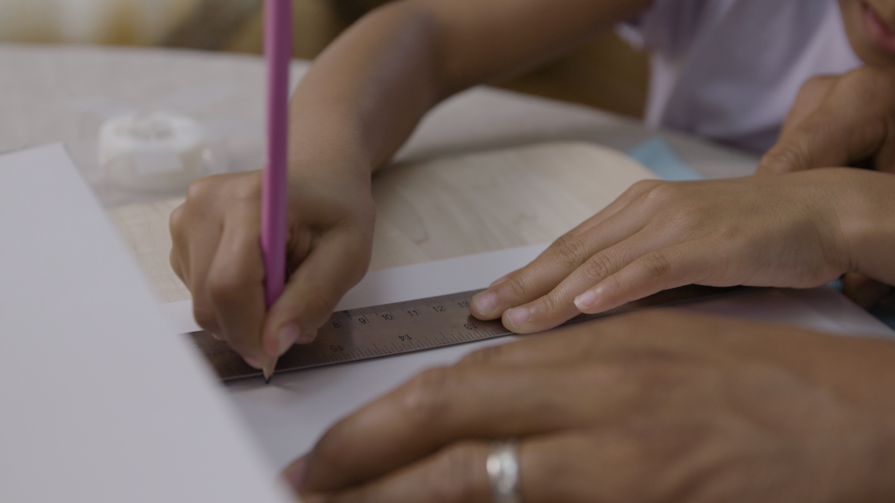
Using a ruler and pencil, have your kid draw the outline for a flap in the box. Then have the parent take a pen knife and cut out the flap that will act as the oven door.

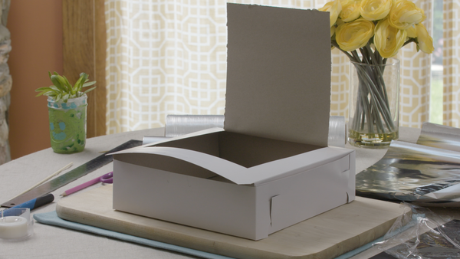

Step 2: Line the Box with Aluminum Foil
Cover the floor, walls, and lid of the box with aluminum foil. Secure this all with scotch tape.
Sponsored by Lance
Looking for a delicious snack that is wholesome and fun? Lance’s sandwich crackers are two awesomes with an incredible in between, and they’ve made them that way for 100 years.

Step 3: Prop open the flap.
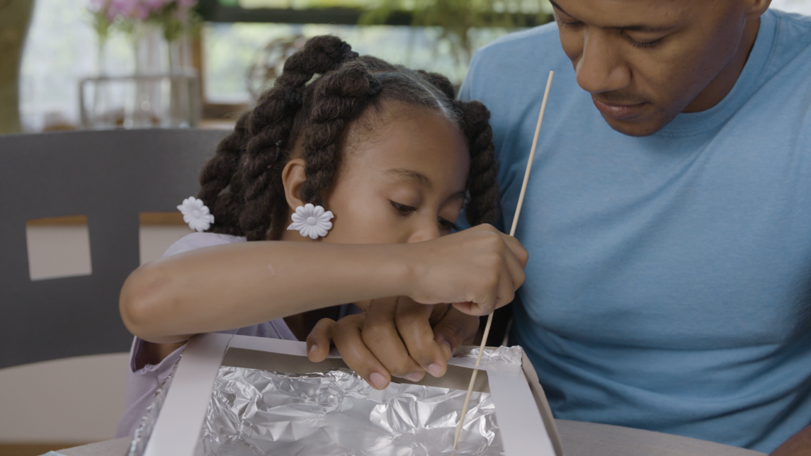
Take a wooden skewer — the kind you buy for shish kabobs at the grocery store — and place it in the corner of the box. Attach the other end of the skewer to the top of the lid with tape.
ADVERTISEMENT

Step 4: Assemble your marshmallows.
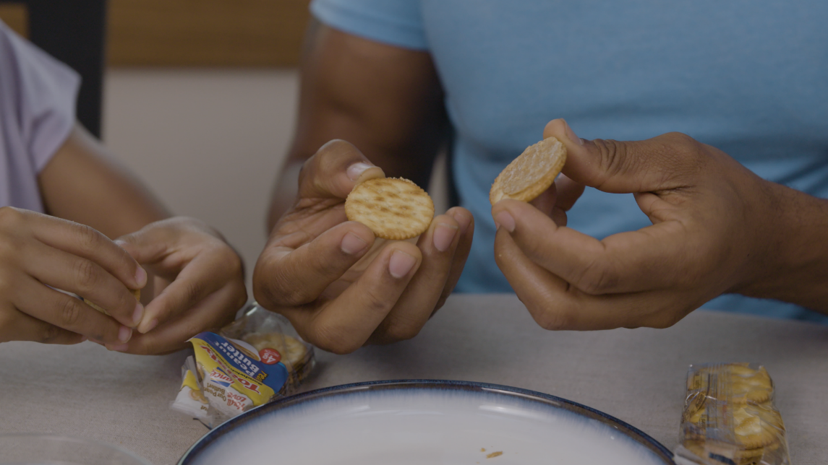
Open up a pack of Toasty® sandwich crackers and twist them in half. Add a marshmallow to the top of the most peanut buttery half (feel free to munch on the other half).
ADVERTISEMENT
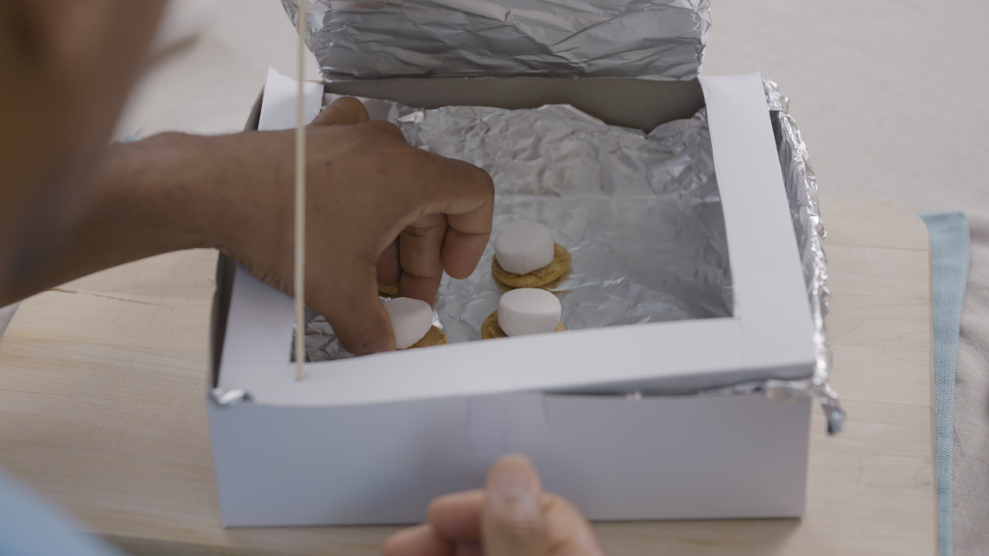

Step 5: Let it bake.
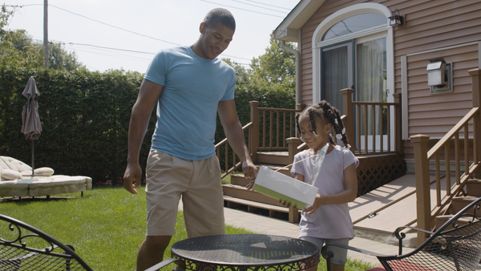
Cover the cracker-marshmallows with saran wrap and then place the box in direct sunlight until the marshmallows start to melt — about 30 minutes to an hour on a clear, sunny day.
ADVERTISEMENT

Step 6: Share the science.
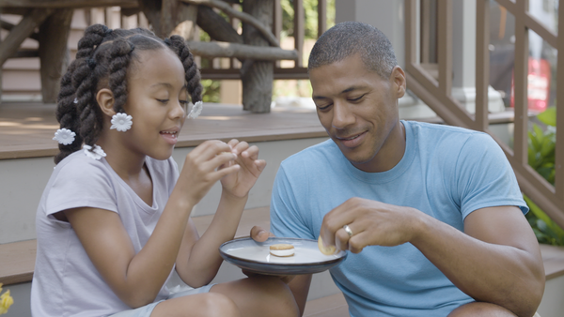
Share the moment over this well-earned, tasty afternoon treat.

