13.6 Volumes of spheres

Focus question: Why might you want to find the volume of a sphere?

Vocabulary:

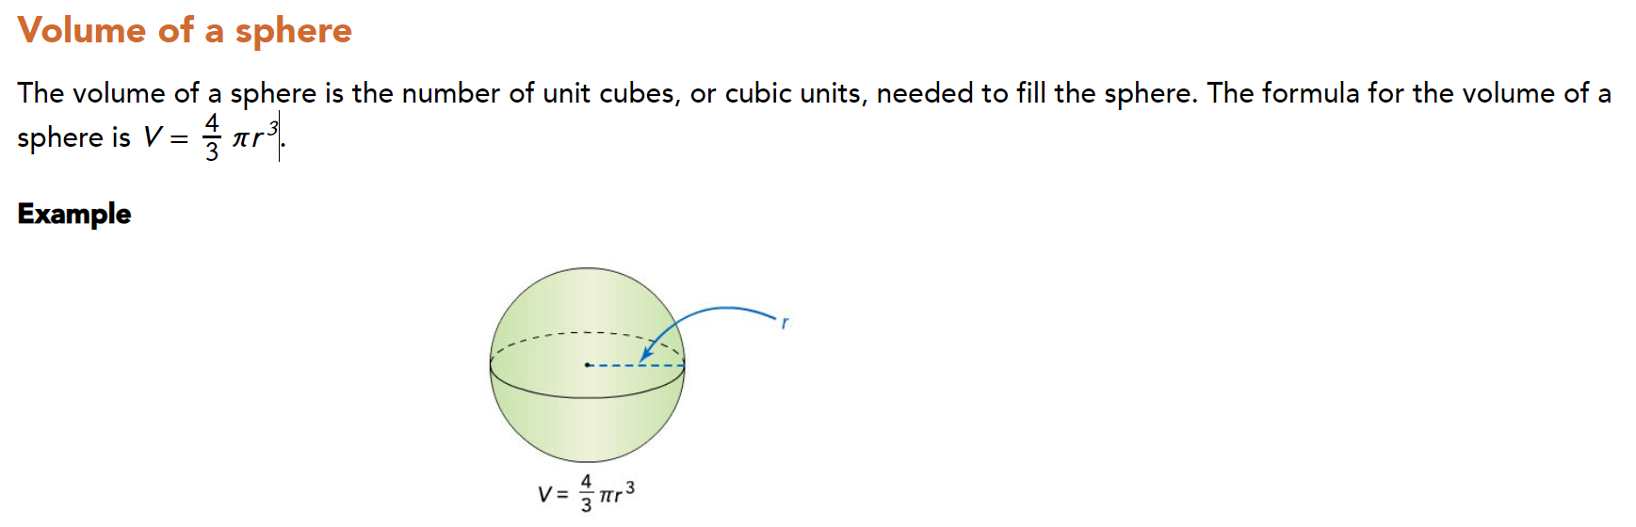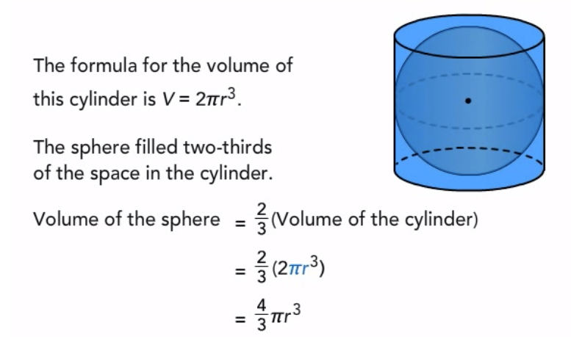

\

Part1

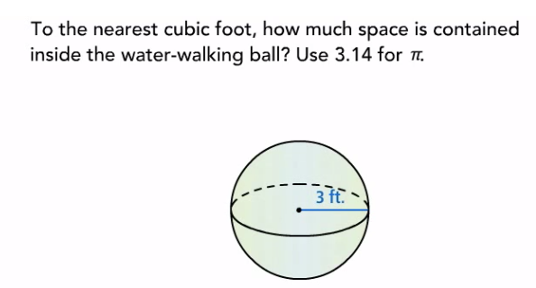

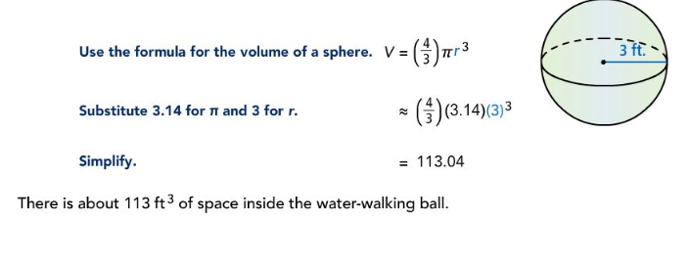

Try:

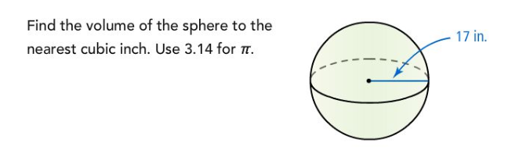

Part2:

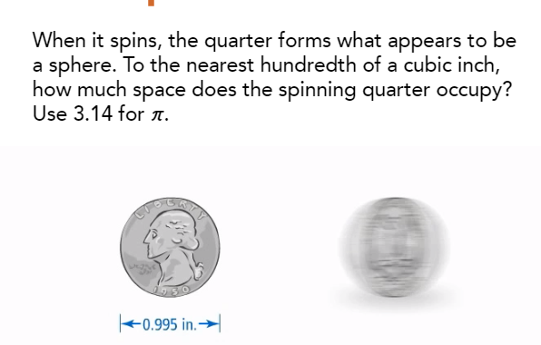

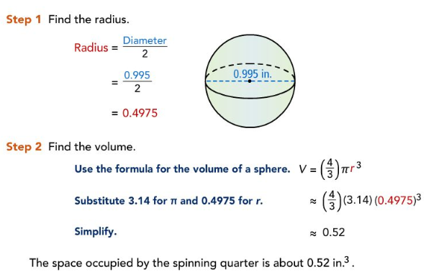

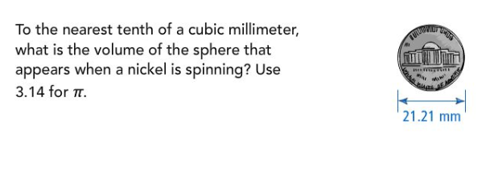Try:

Answer_________________

Part3:

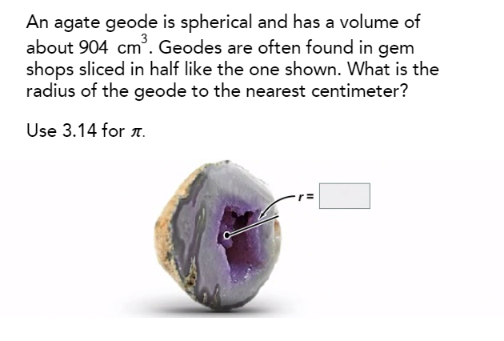

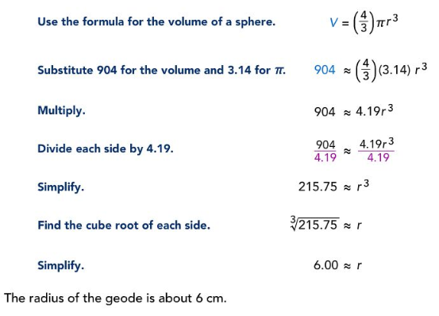

Try:

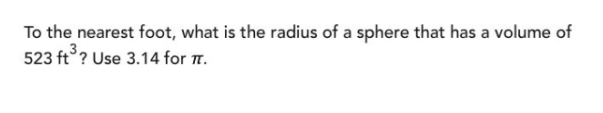

Answer__________________

Summary: 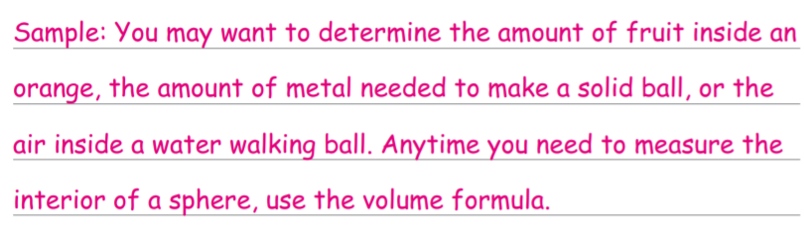

Answers

Try Part1: ${20569in}^{3}$

Try part2: ${4,993.5mm}^{3}$

Try part3: 5ft